|  |
| --- |

**GARAGE MANAGEMENT SYSTEM**

COLLEGE NAME :

**GOVERNMENT ARTS AND SCIENCE COLLEGE**

**(AVINASHI)**

COLLEGE CODE : bruau

TEAM ID : **NM2025TMID20836**

TEAM MEMBERS :

TEAM LEAD : ARJUN M

EMAIL ID : [arjunmuthu965@gmail.com](mailto:arjunmuthu965@gmail.com)

TEAM MEMBER : GOKUL K

EMAIL ID : [gokulkaliyappan2006@gmail.com](mailto:gokulkaliyappan2006@gmail.com)

TEAM MEMBER : SACHITHANANTHAM T

EMAIL ID : [sachinthangavel@gmail.com](mailto:sachinthangavel@gmail.com)

TEAM MEMBER : SATHYA NARAYANAN N

EMAIL ID : [sakthi769588@gmail.com](mailto:sakthi769588@gmail.com)

# **PROJECT OVERVIEW** :

A Garage Management System (GMS) is specialized software that helps auto repair shops and garages automate and streamline operations, from appointment scheduling and inventory tracking to customer relationship management.  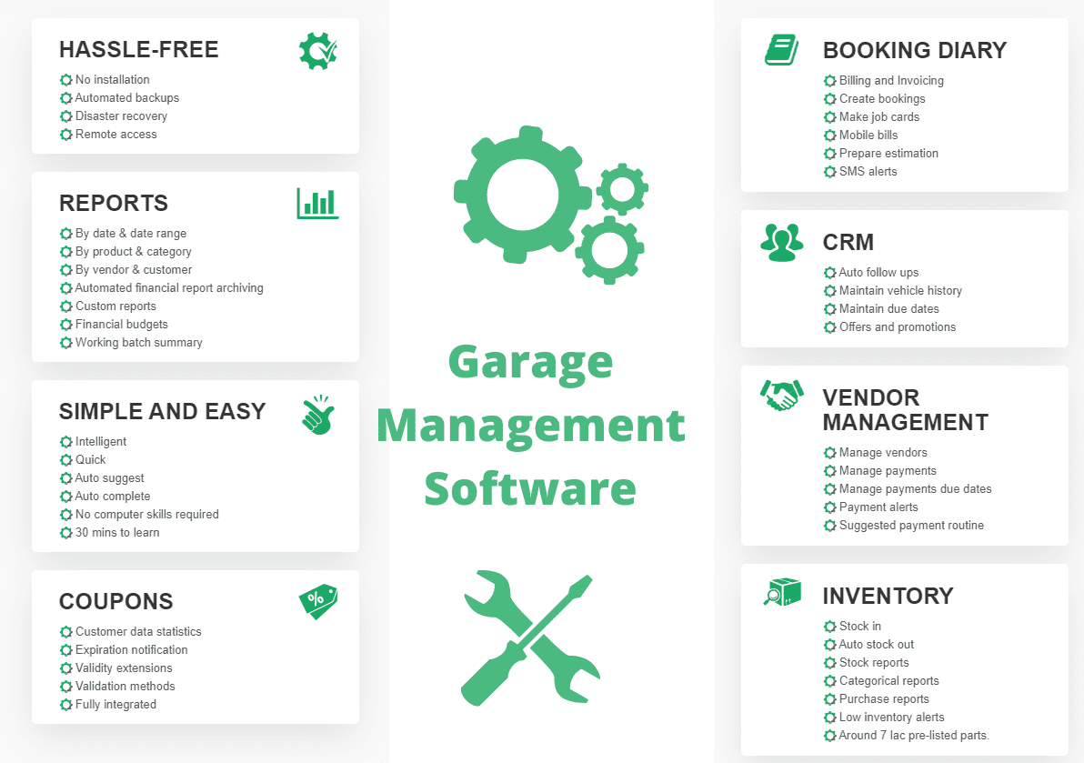

# **OBJECTIVES :**

The main objectives of a garage management system (GMS) are to  streamline operations, improe efficiency enhance customer experience, and increase profitability by centralizing tasks like appointment scheduling, inventory management, customer tracking, and financial reporting into a unified platform. It automates manual work, reduces errors, provides data-driven insights for better decision-making, and builds customer loyalty through improved communication and service.

**DEVELOPMENT PHASE :**

* Creating Developer Account : By using this URL – <https://www.salesforce.com/form/developer-signup/?d=pb>

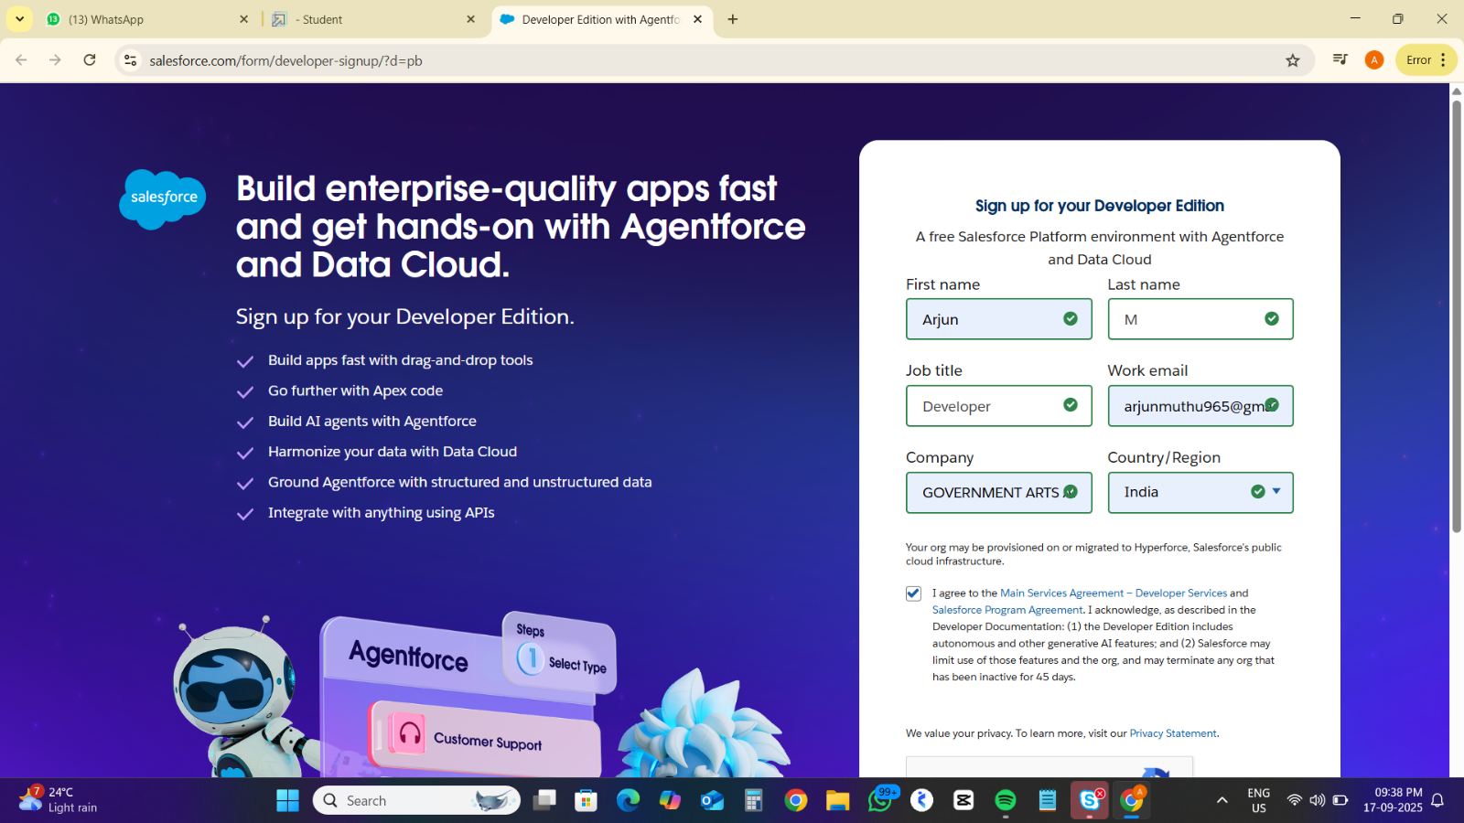

* + - * Created Objects :
  + Customer Details

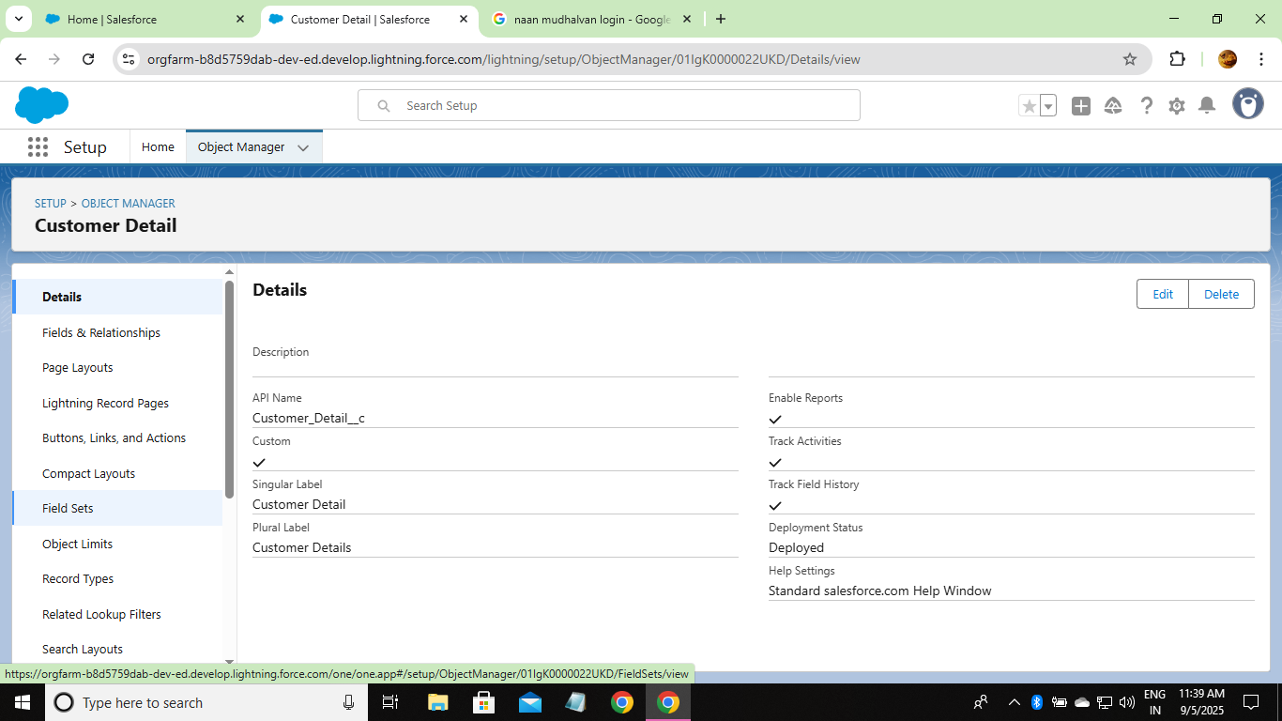

* + Appointment

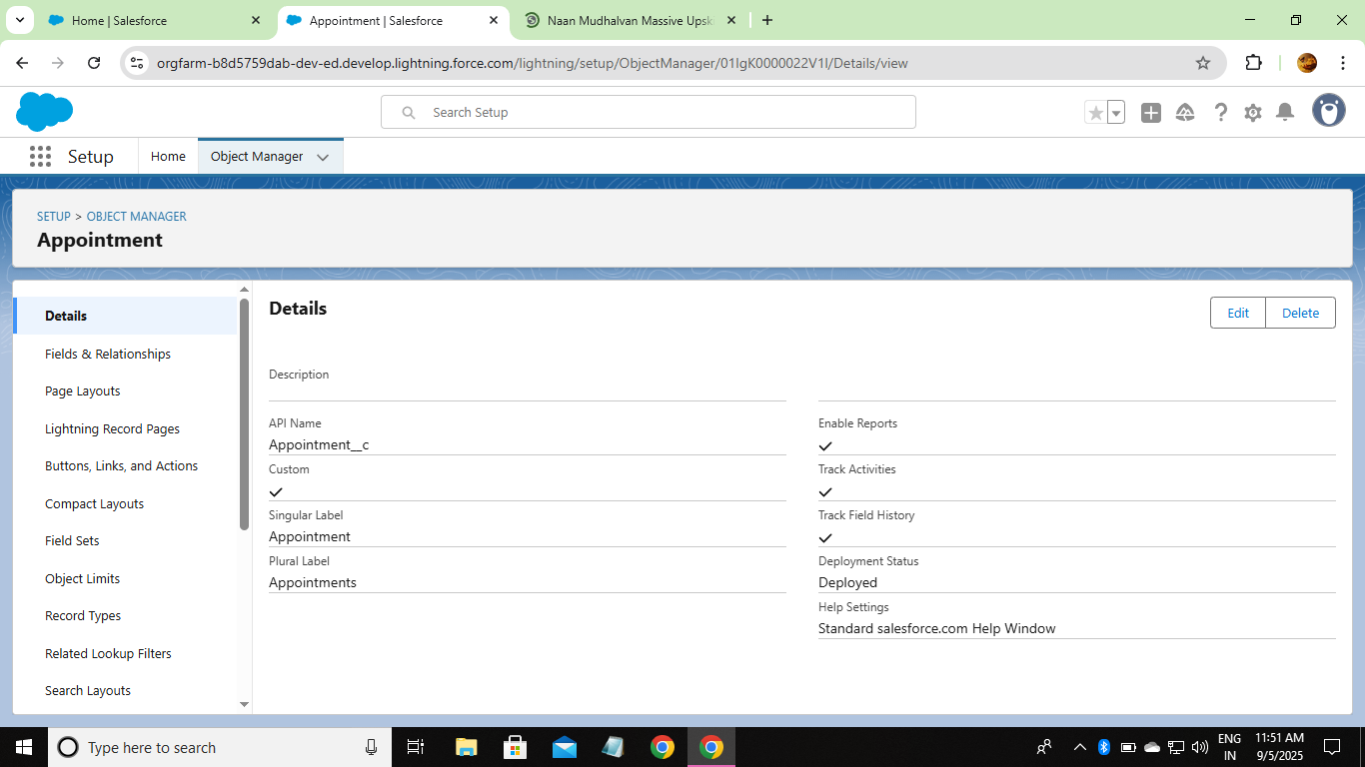

* + Service Record

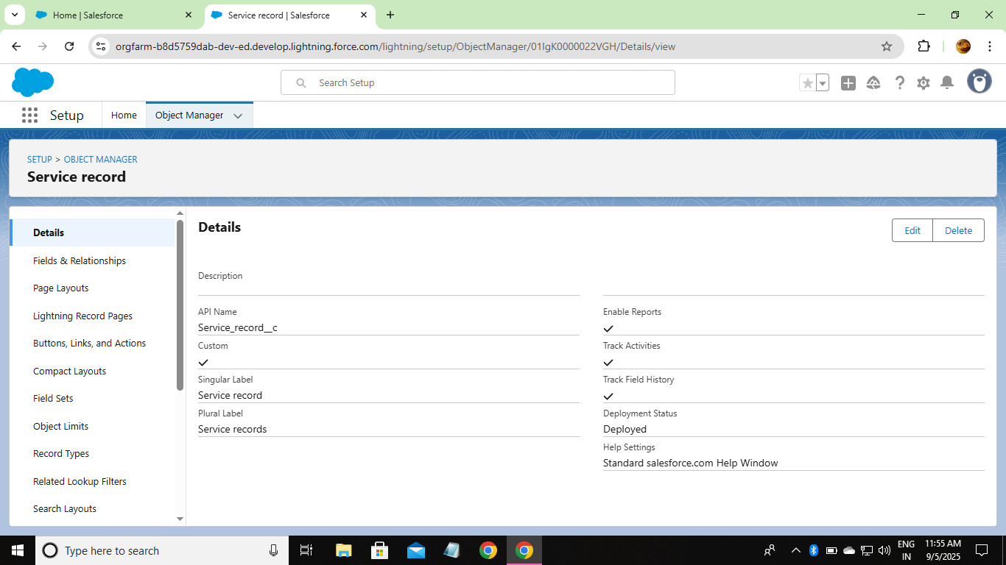

* + Billing Details and Feedback

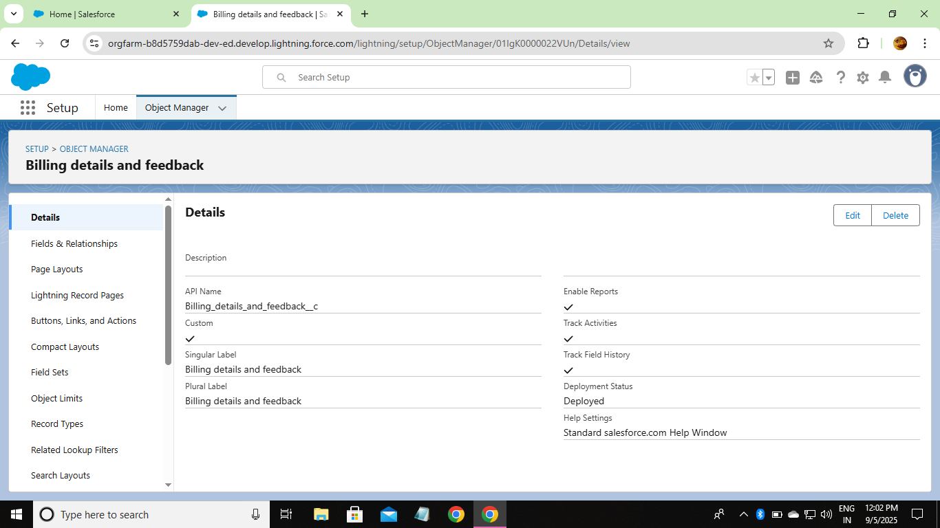

* + - * Created Custom Tabs :

Customer Details

Appointment

Service Record

Billing Details and Feedback

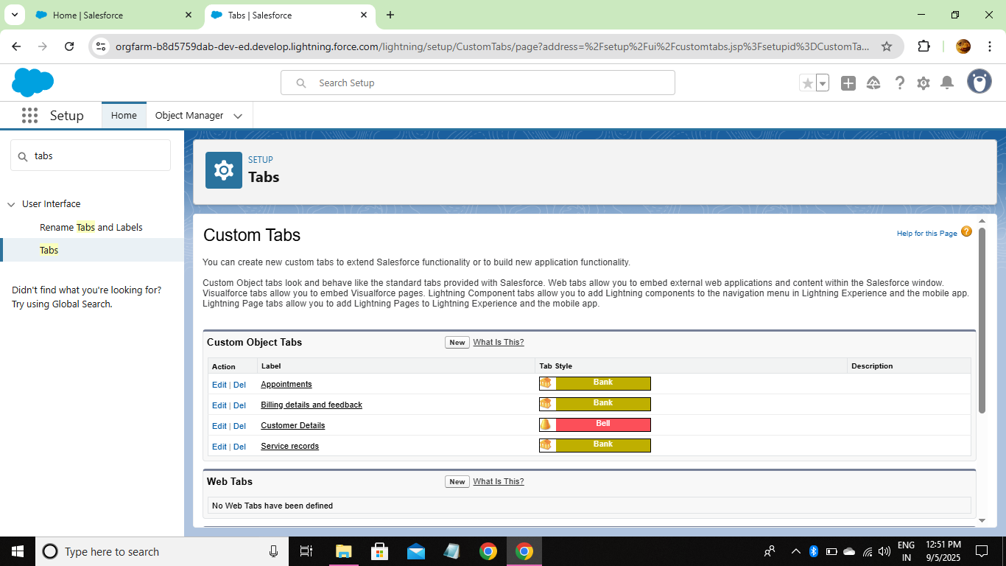

* + - Developed Lightning App :

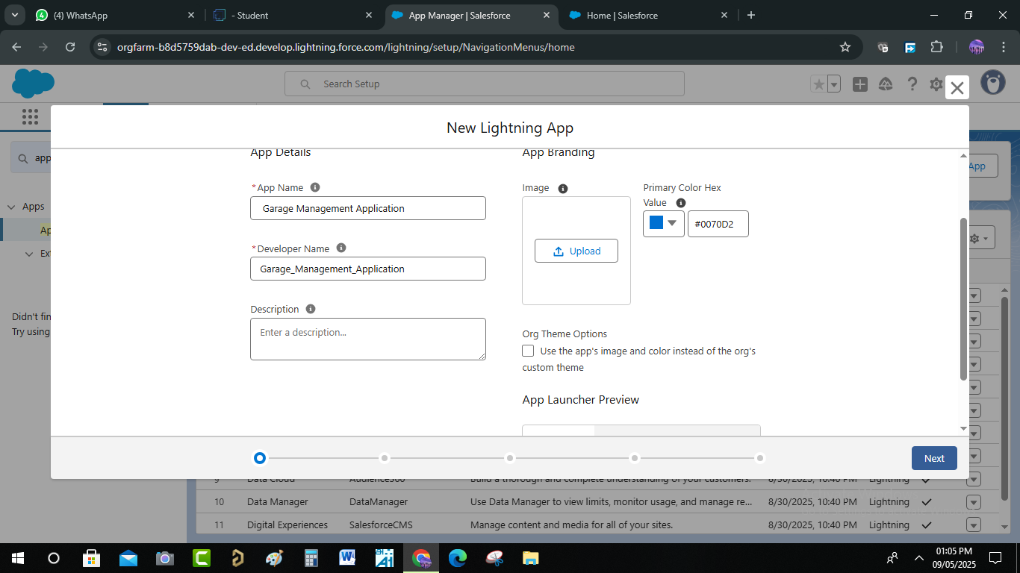

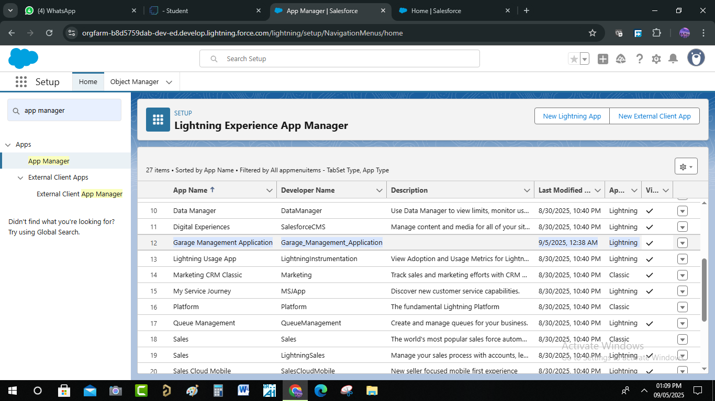

* + - * Created Fields :
  + Customer Details Object

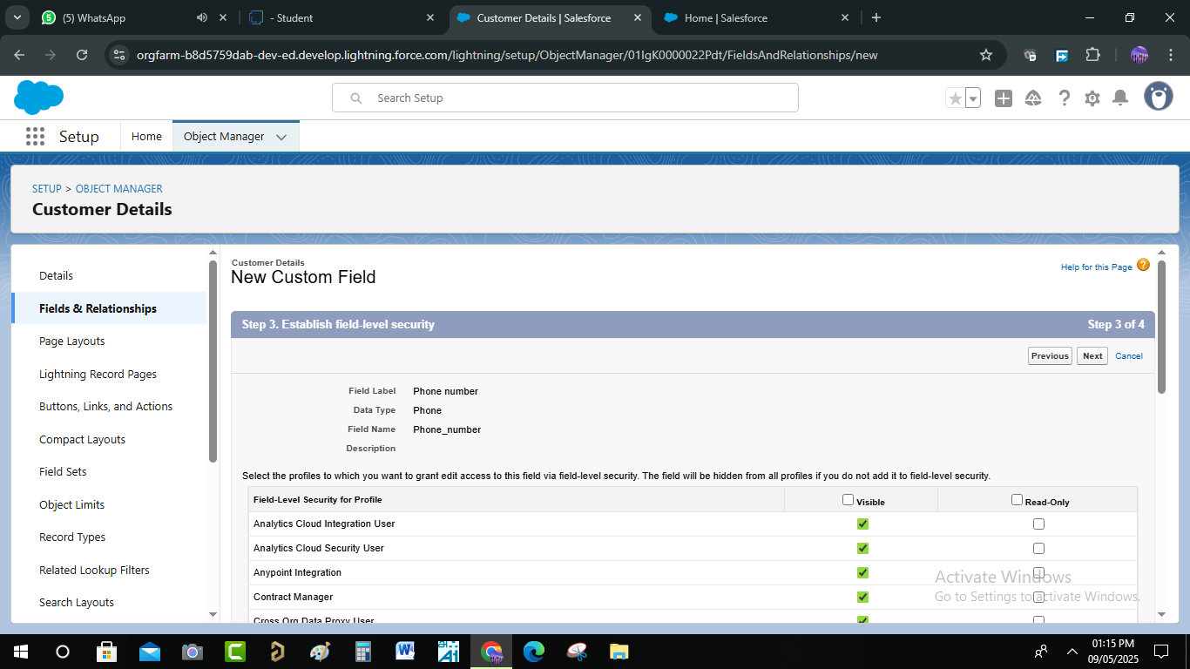

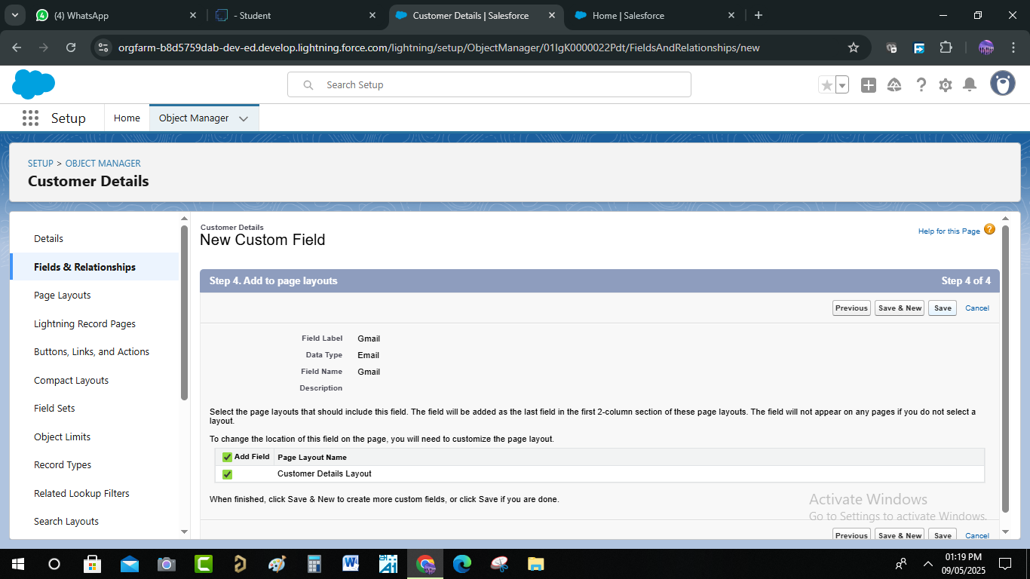

* + Lookup Fields

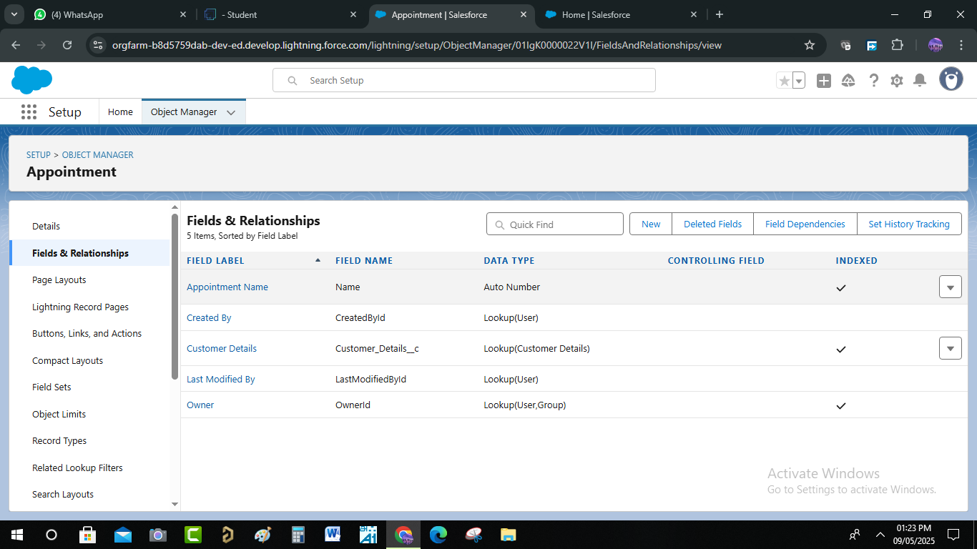

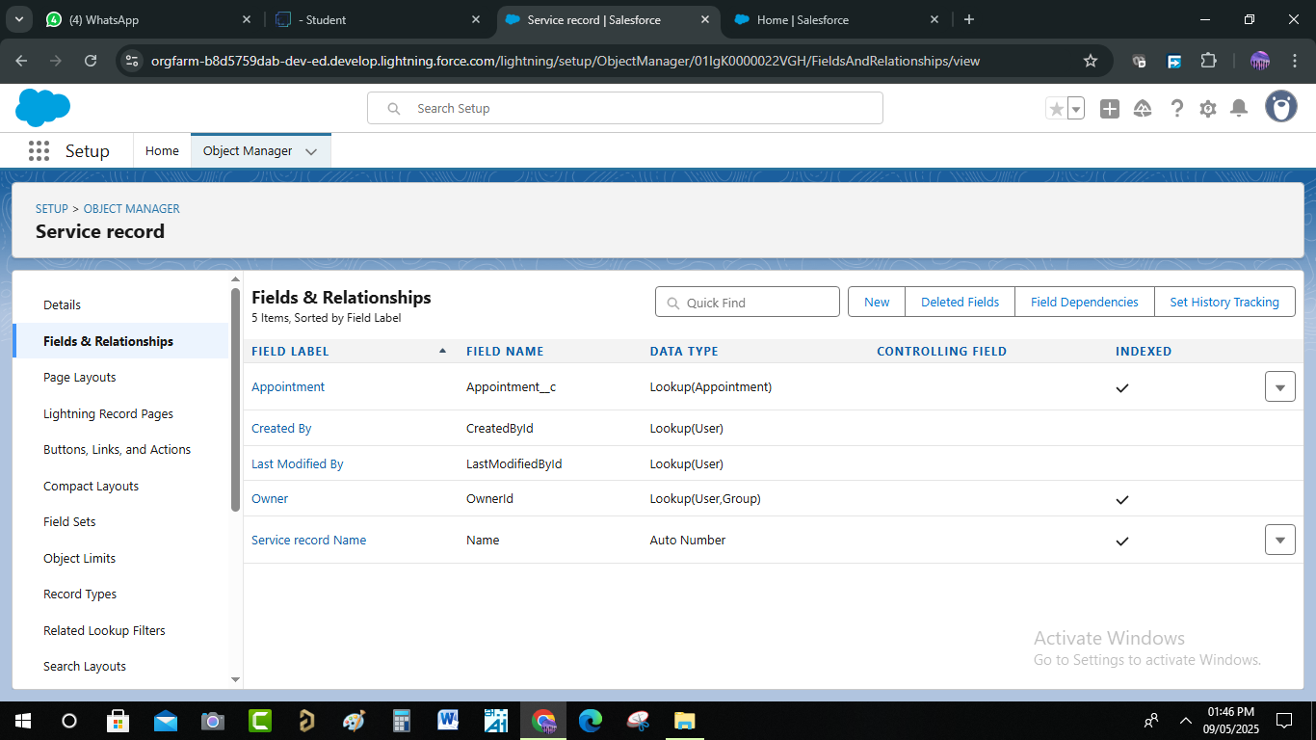

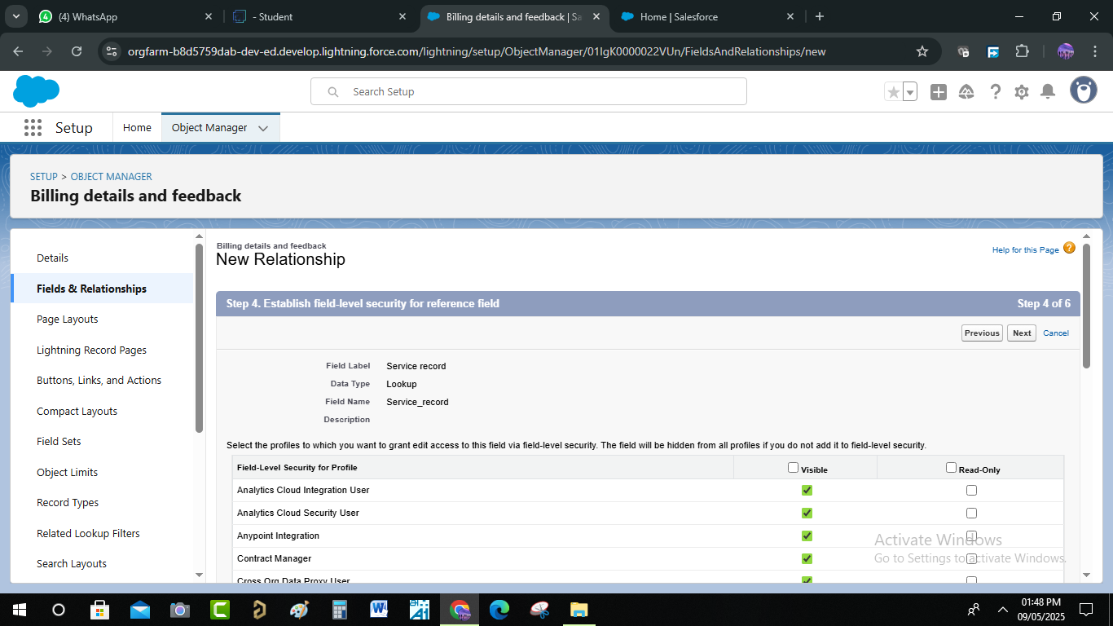

* + Checkbox Fields

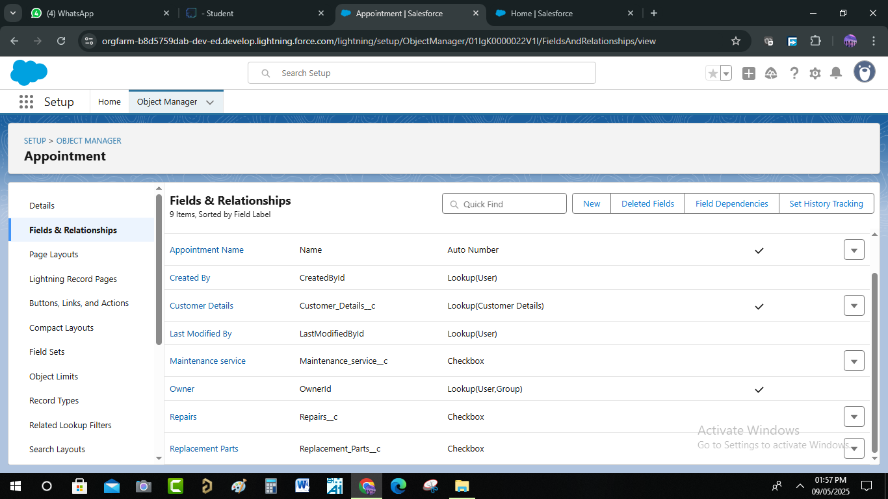

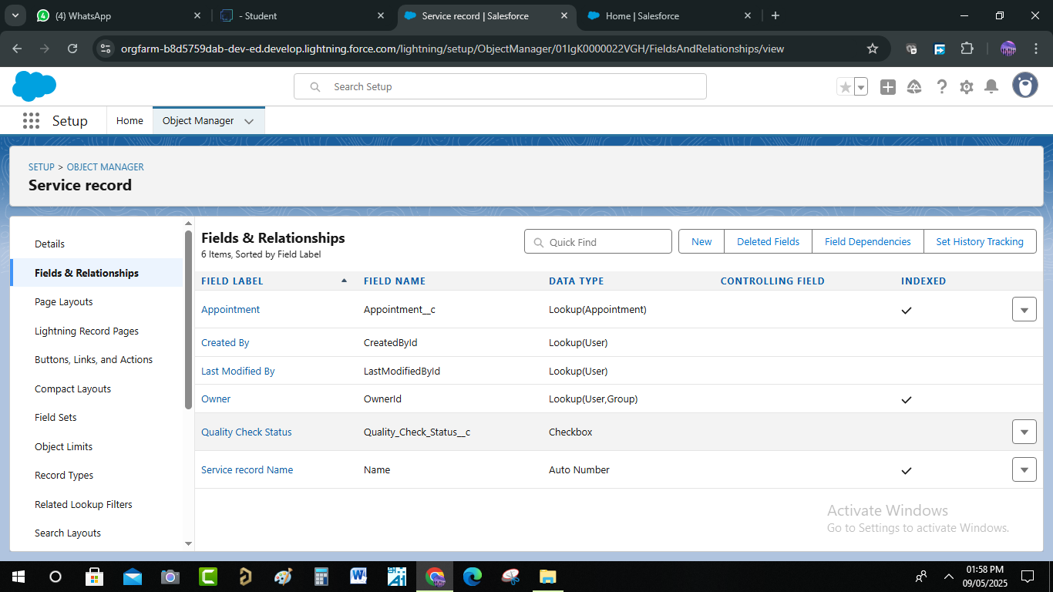

* + Date Fields

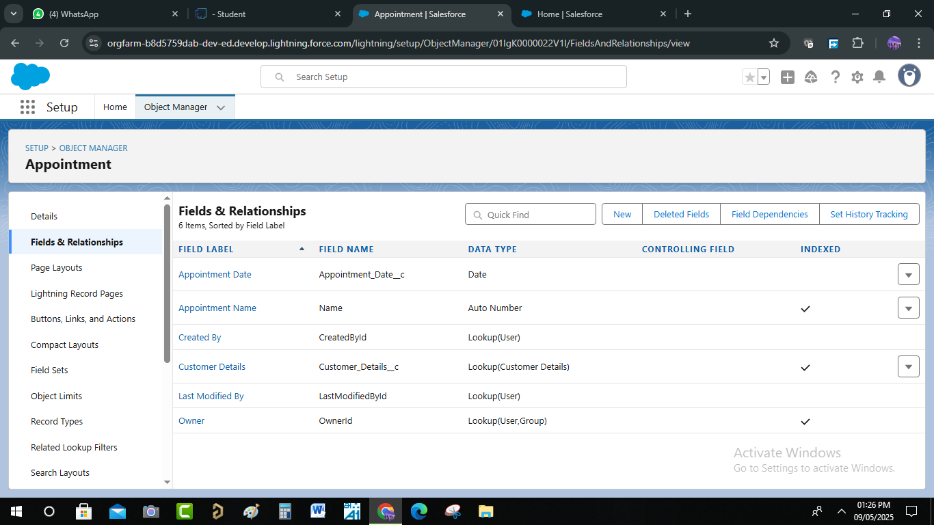

* + Currency Fields

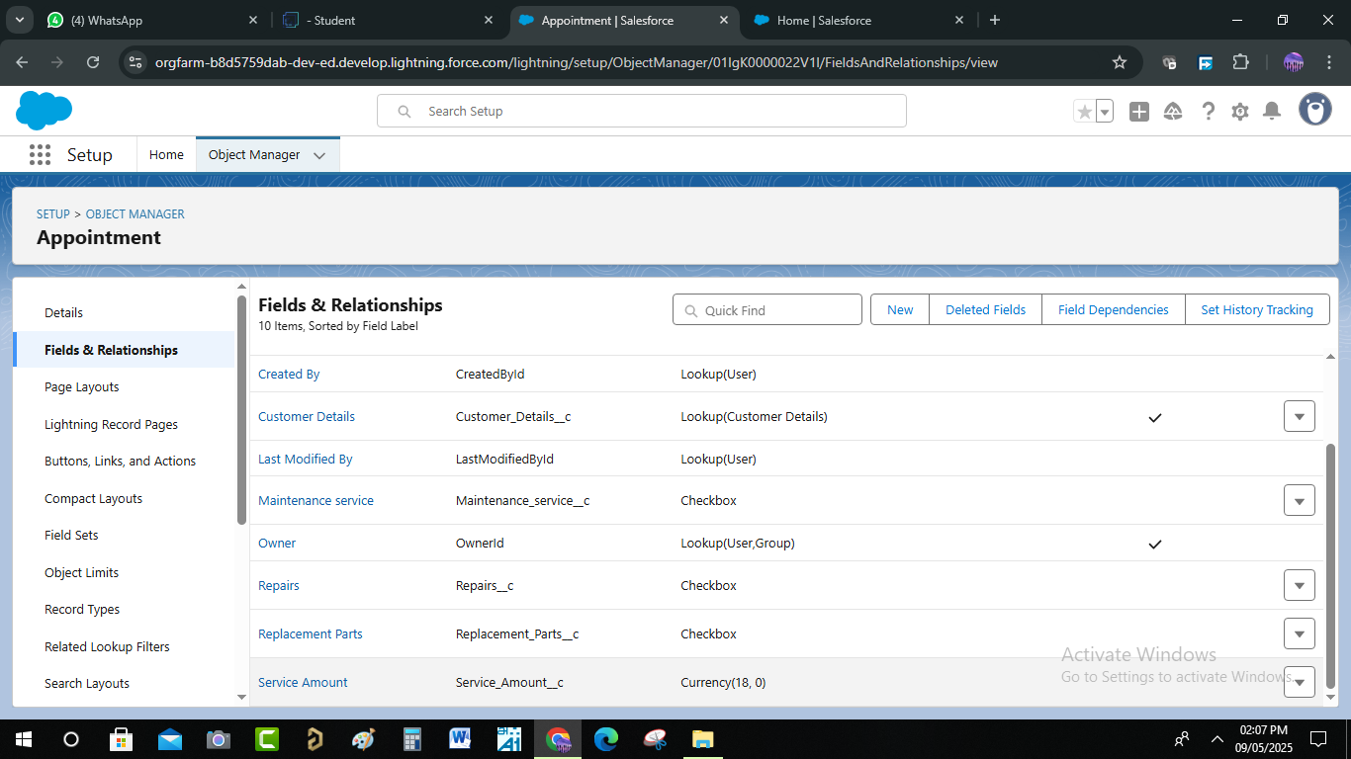

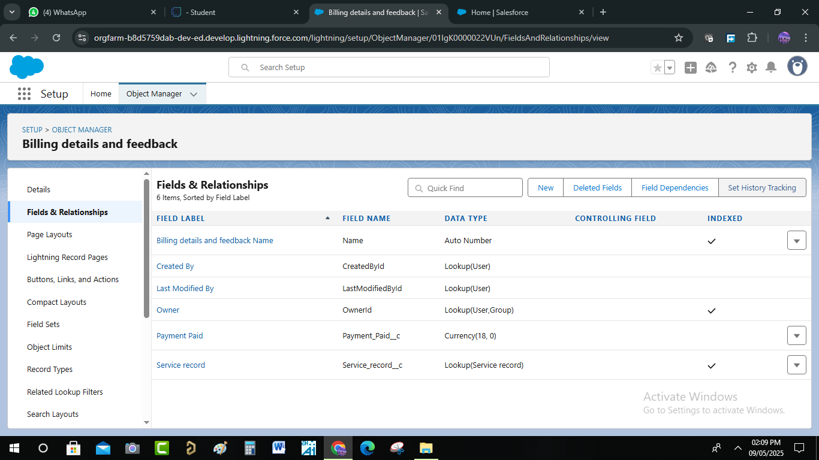

* + Text Fields

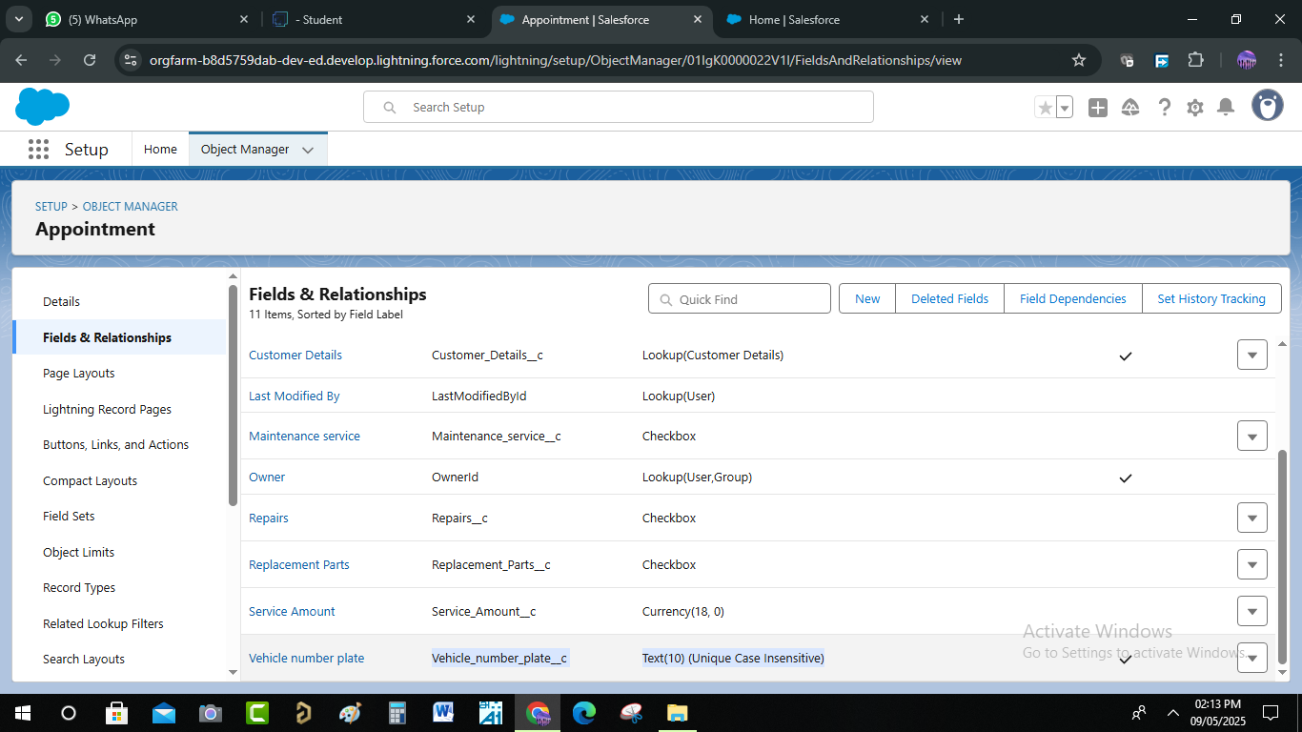

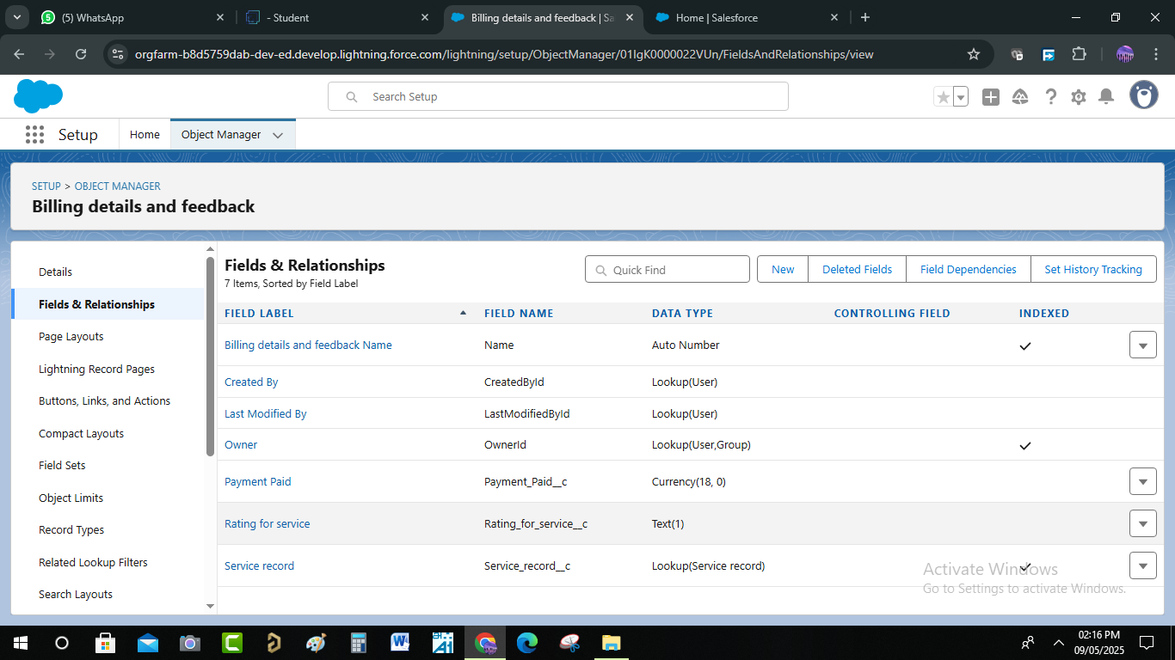

* + Picklist Fields

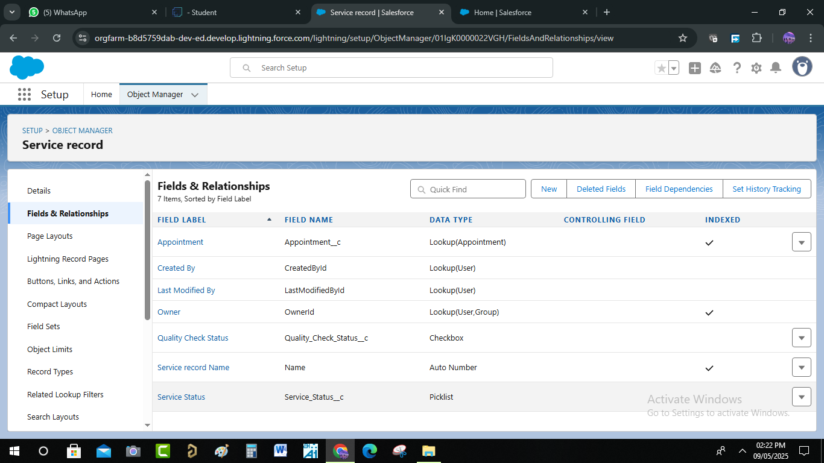

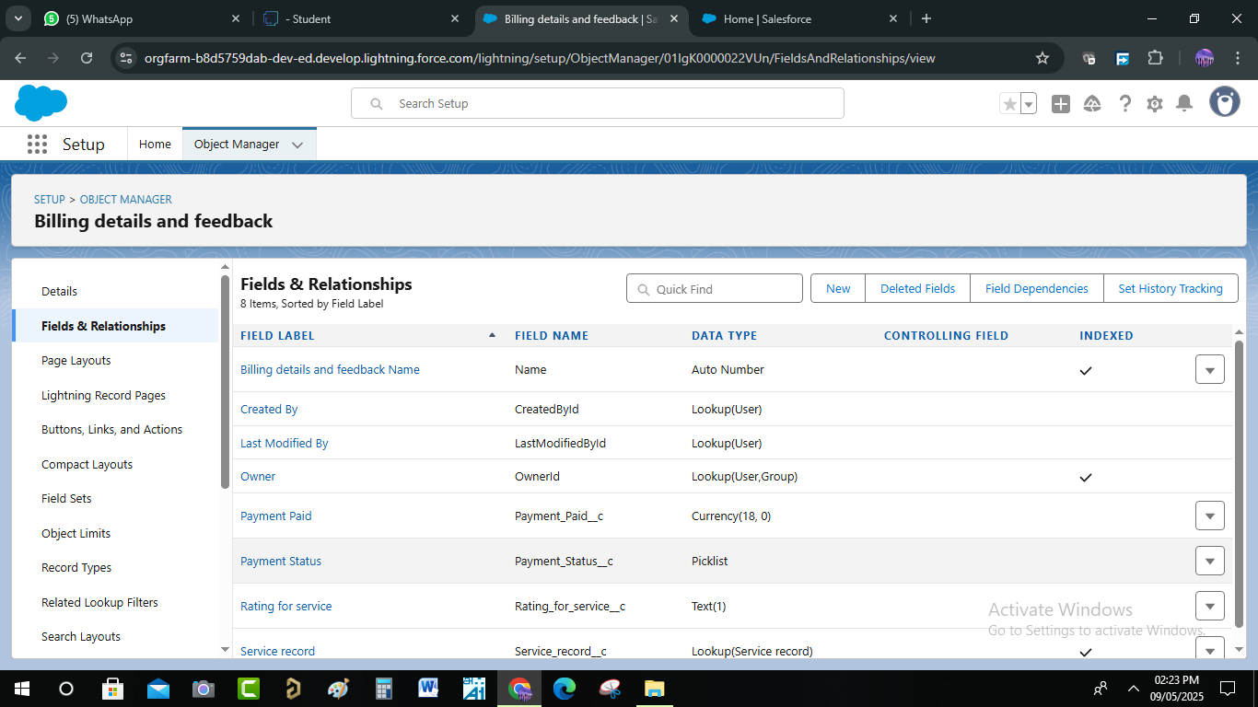

* + Formula Field In Service Record

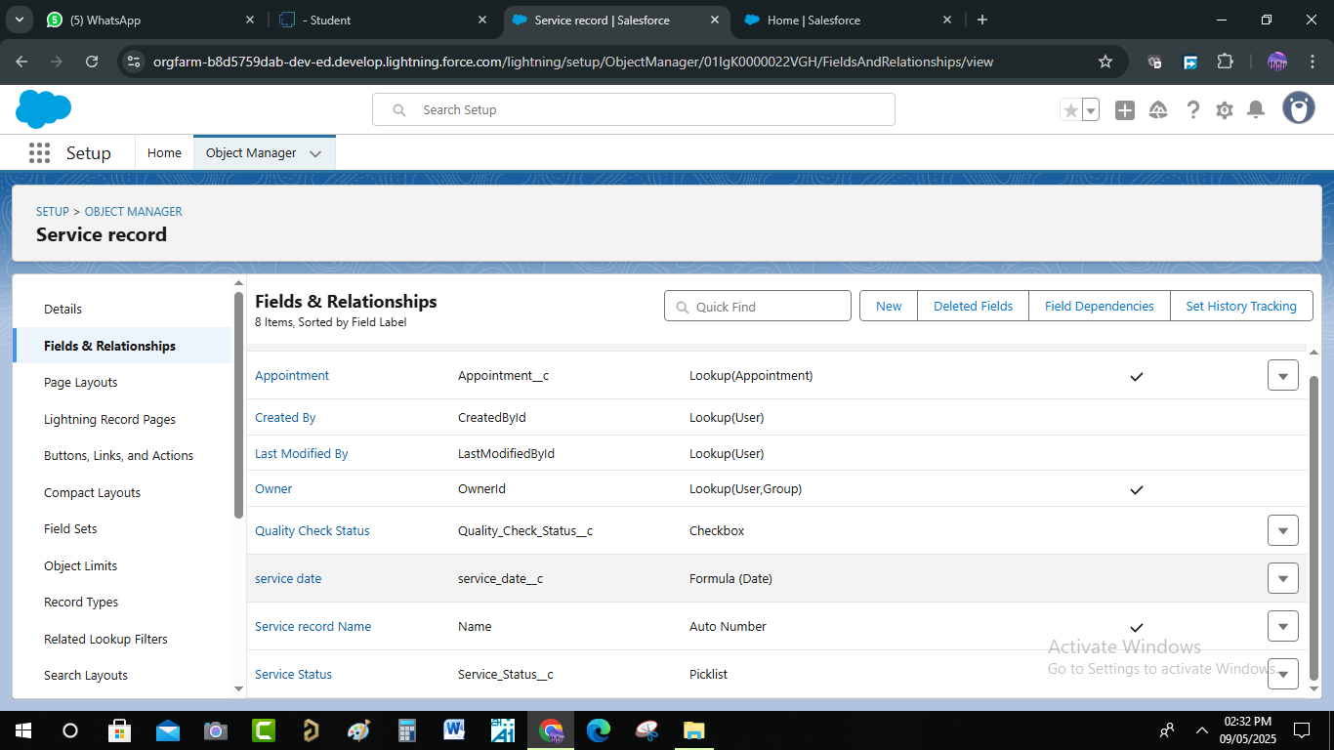

# **Validation Rule :**

Validation in a GMS ensures that the data entered into the system is accurate, complete, and reliable. It prevents errors such as duplicate entries, incorrect service details, or invalid customer/vehicle information**.**

# **Typical validations include**:

Customer Data Validation – checks if contact details, email, and phone numbers are valid.

* Vehicle Information Validation – verifies vehicle number, model, and service history consistency.
* Service & Appointment Validation – Ensures correct service selection, valid dates/times, and no double booking.
* Payment Validation – confirms correct billing amounts, payment modes, and invoice generation.
* System Validation Rules – prevent missing mandatory fields and enforce business rules (e.g., warranty claims only for eligible vehicles).
* A Validation Rule To An Appointment Object

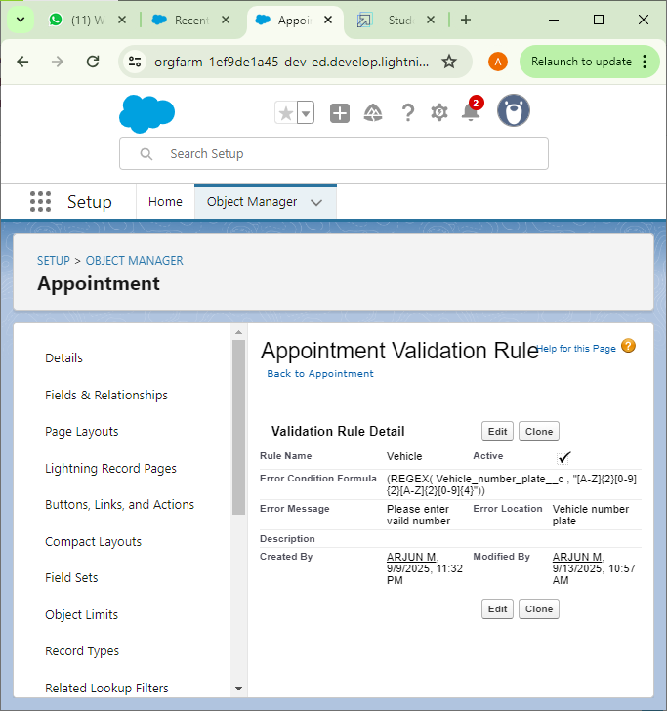

* A Validation Rule To An Billing Details And Feedback Object

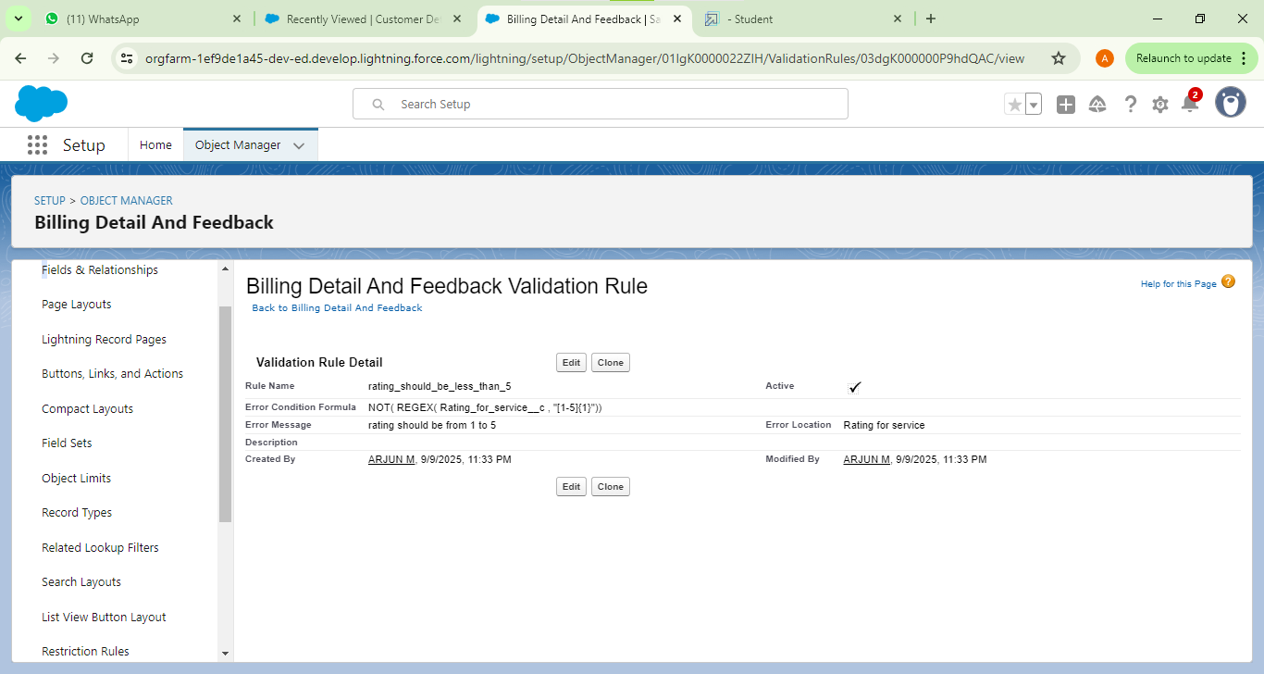

* + - * Duplicate Rule :
* AMatching Rule To An Customer Details Object

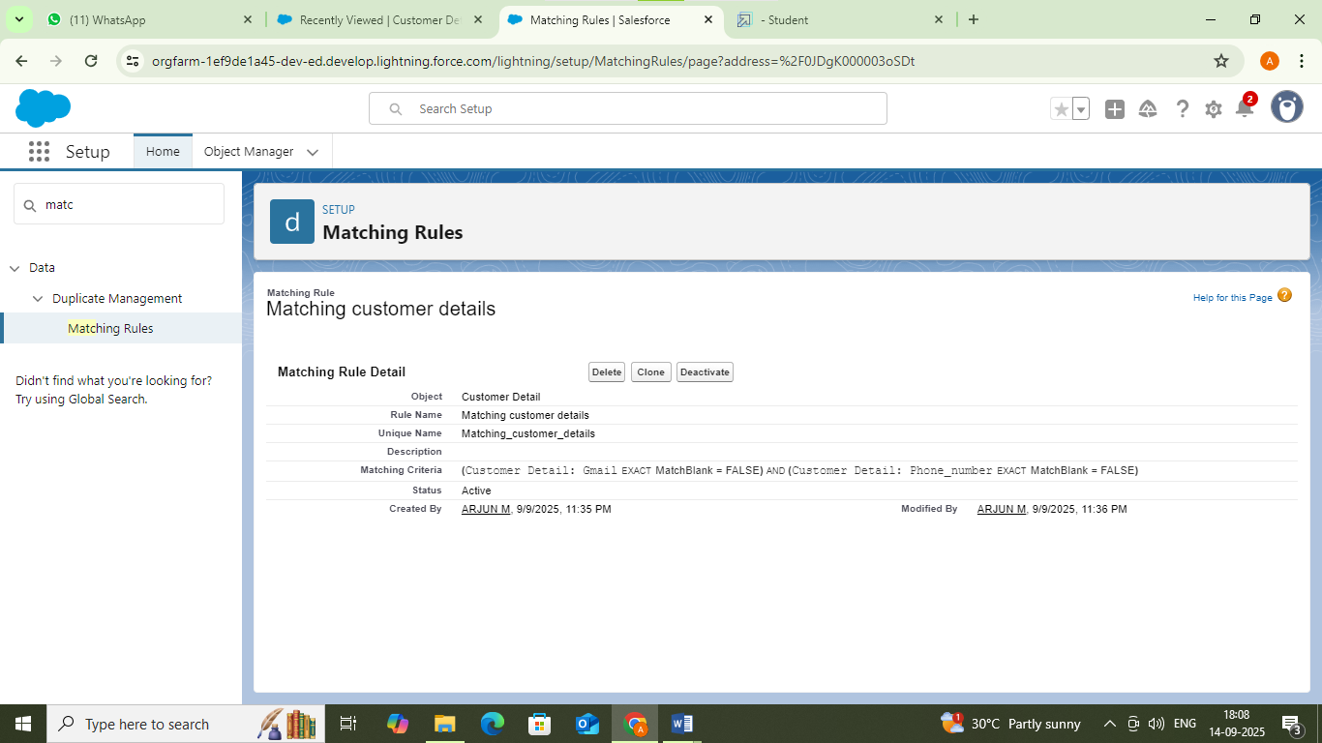

* A Duplicate Rule To An Customer Details Object

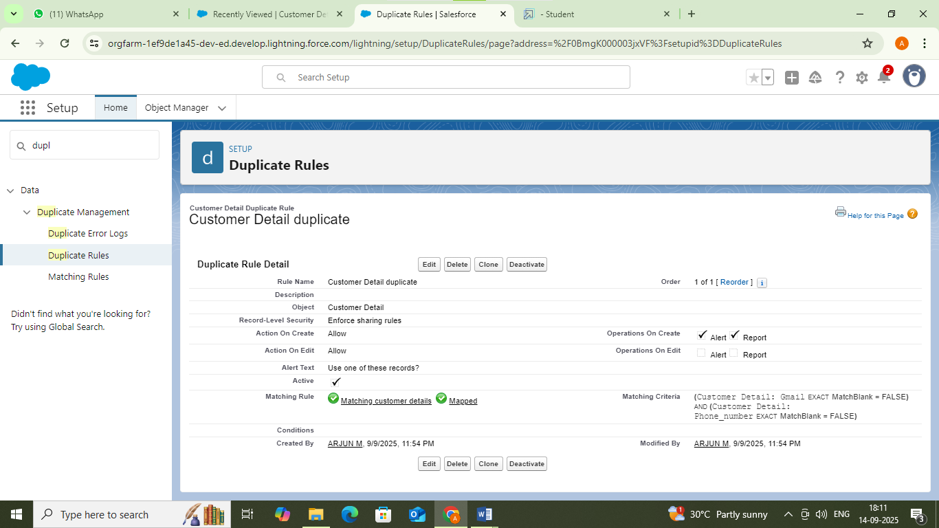

* + - * Created Profiles :
* Manager Profile

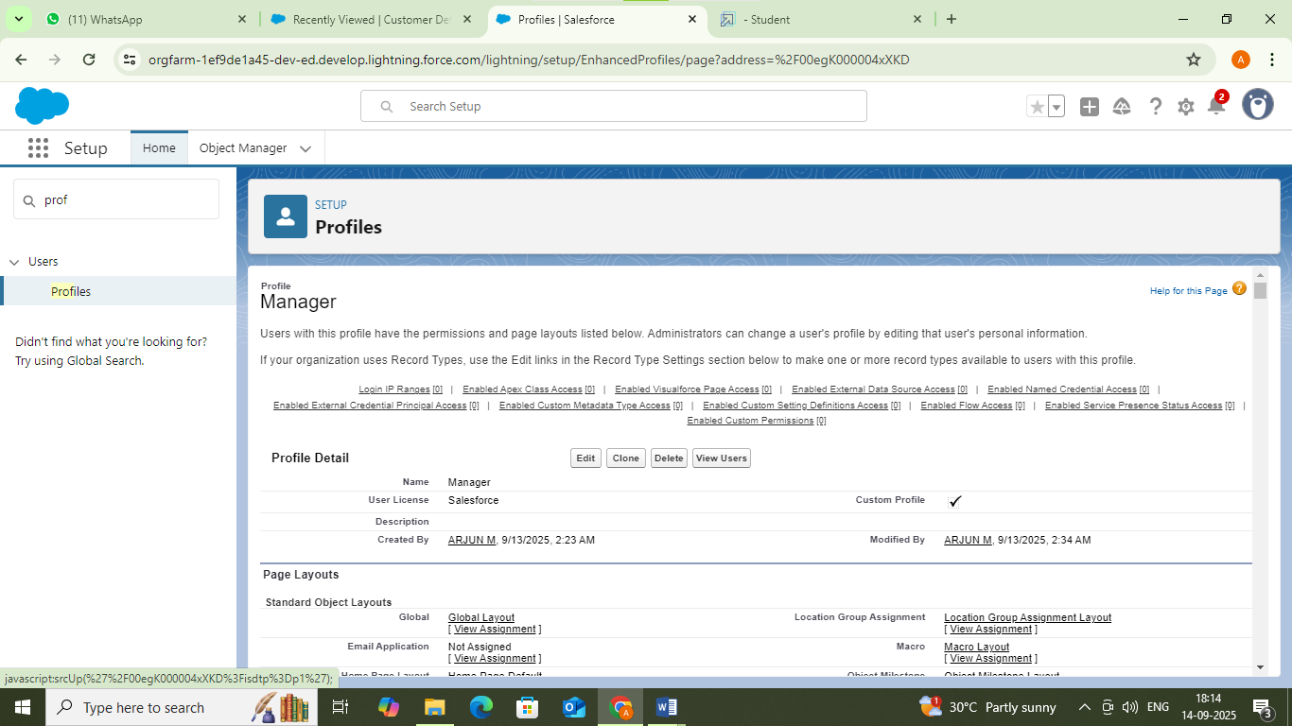

* Sales Person Profile

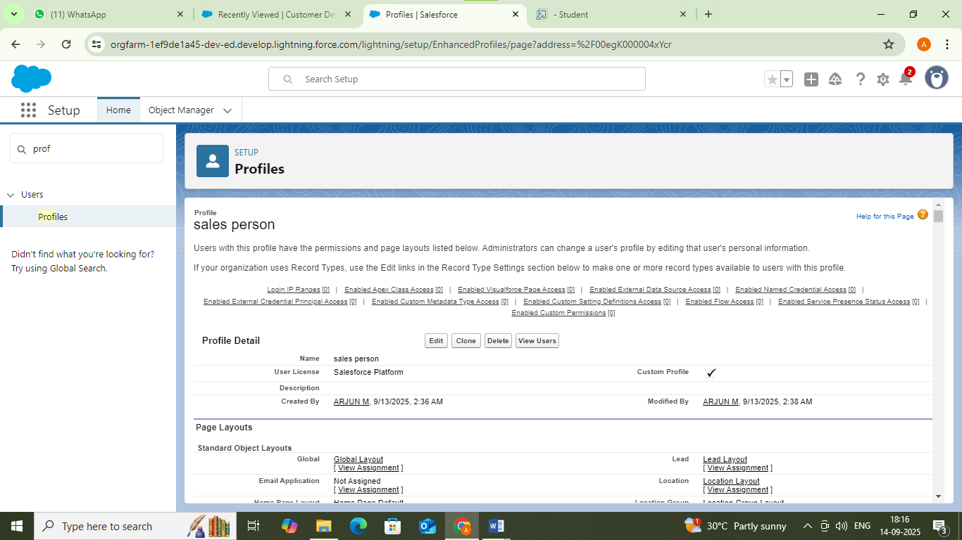

* + - * Role & Role Hierarchy :
* Manager role

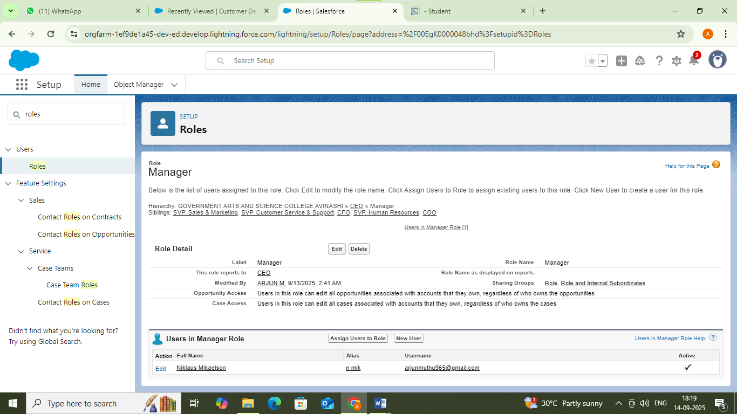

* Salesperson role

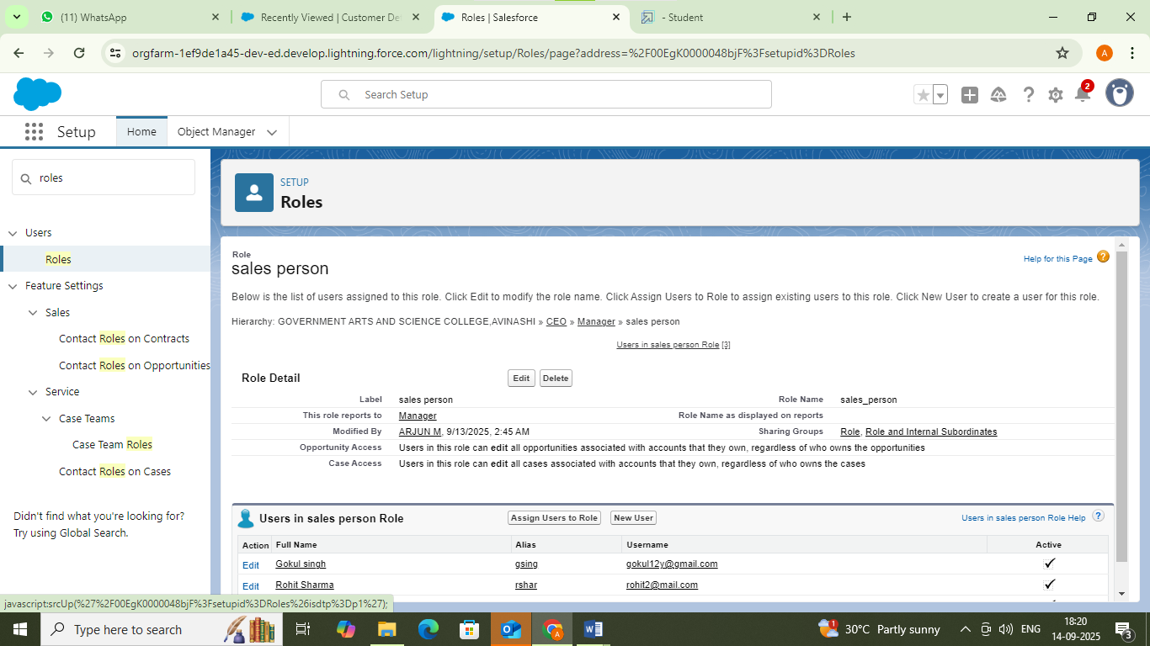

* + - * Created Users :
* User

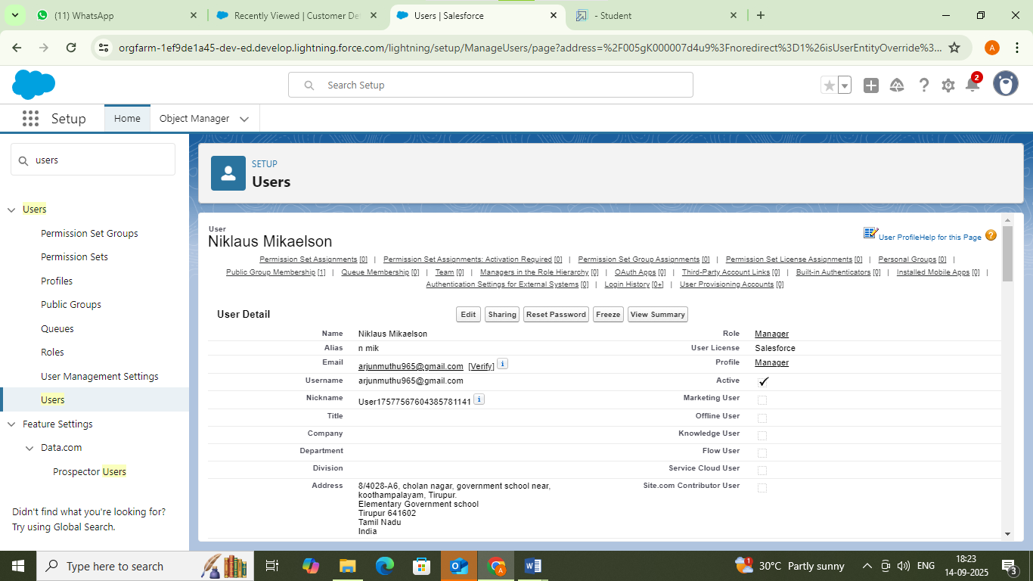

* Another Users

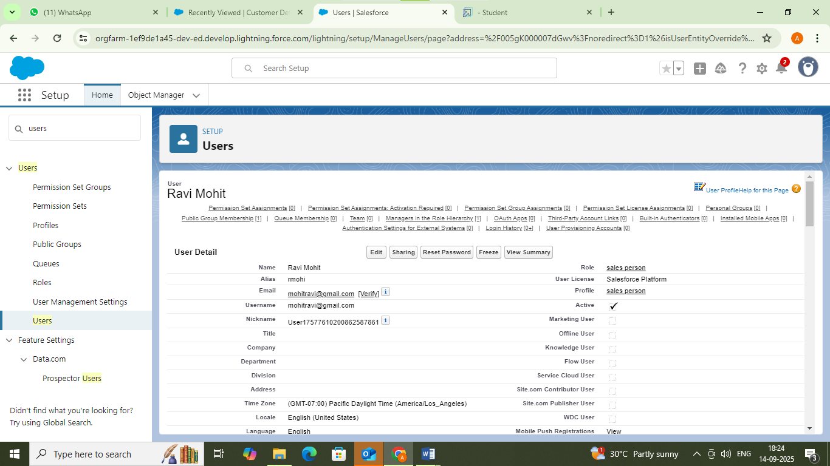

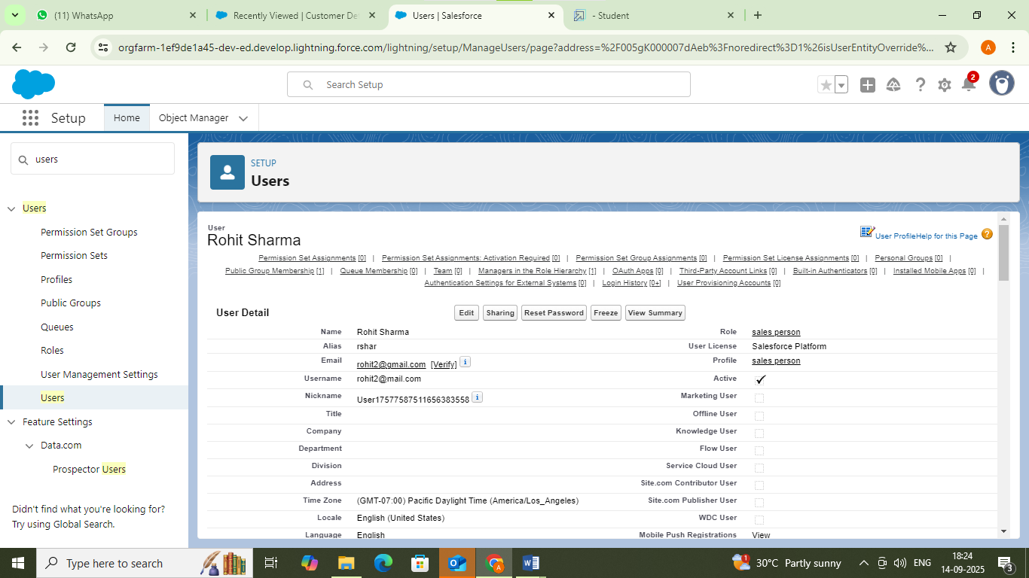

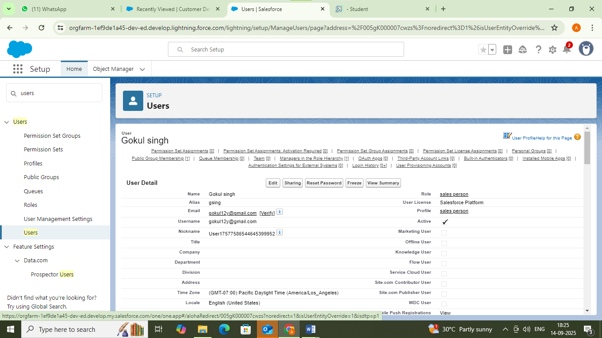

* + - * Public Groups :

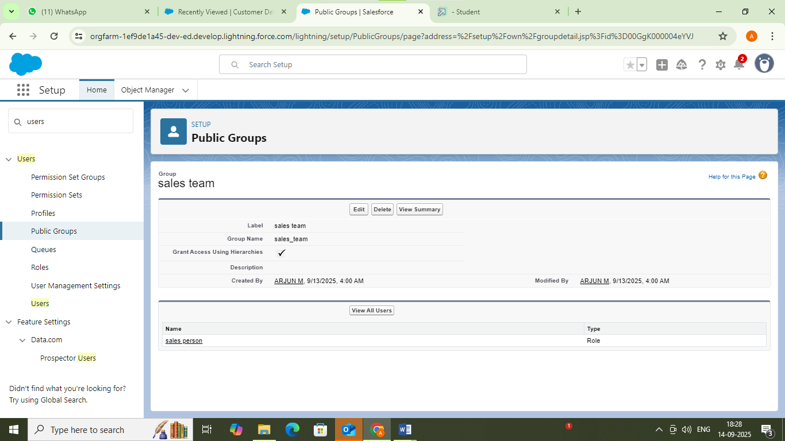

* + - * Sharing Settings

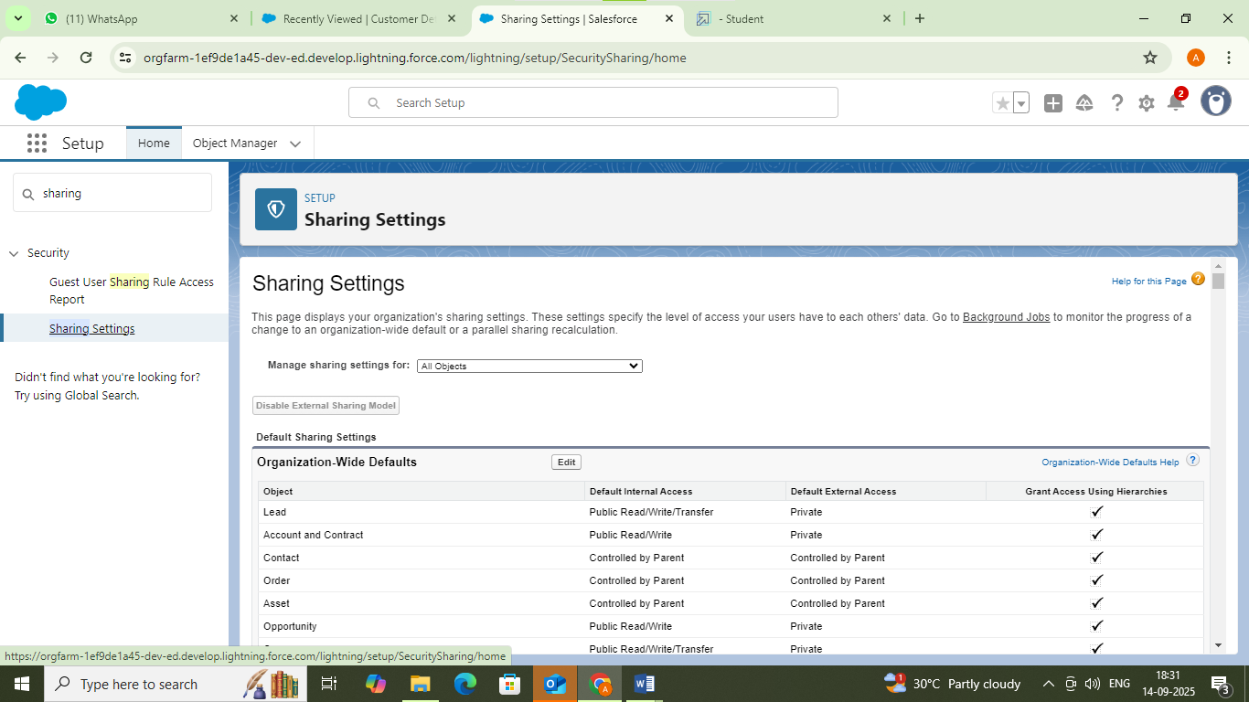

* + - * Created Flows :
* Flow
* **Test Scenarios**
* Create new Billing record with valid Customer Email → Flow should update amount and send email.
* Create new Billing record without Customer Email → Flow should update amount but skip email alert.
* Update existing Billing record → Verify if email alert re-triggers or not (based on design).
* Invalid email format → Flow should log error or not send email.
* High data volume (bulk test) → Insert/update 50+ Billing records and check if flow runs without hitting limits

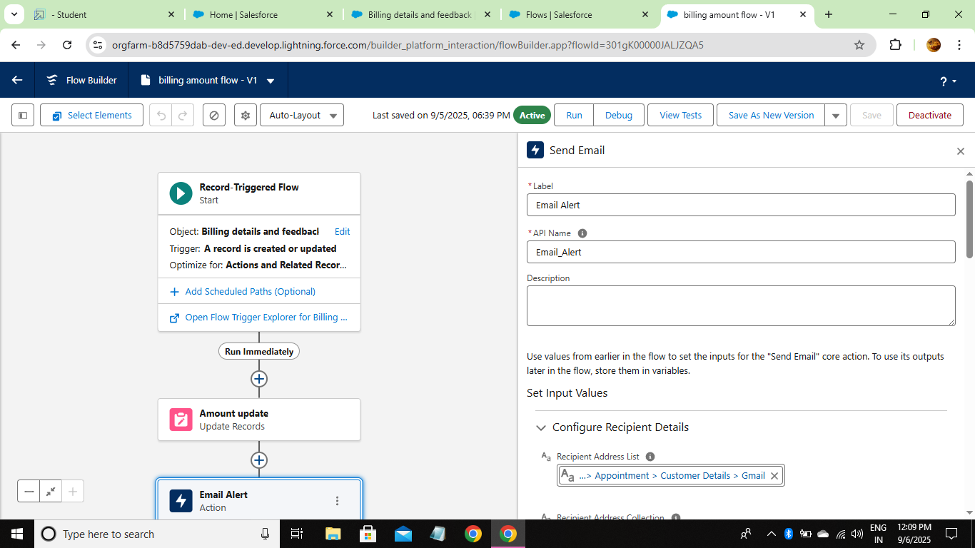

* Another Flow
* **Test Scenarios**
* Create a new Service Record with valid data → Flow should update Service Status/Amount correctly.
* Update an existing Service Record → Check if status is updated as per rules.
* Update record with no change in relevant fields → Flow should not perform unnecessary updates.
* Missing critical field (like Service Type) → Flow should handle gracefully.
* Bulk test (insert/update 50+ service records) → Flow should complete without errors.

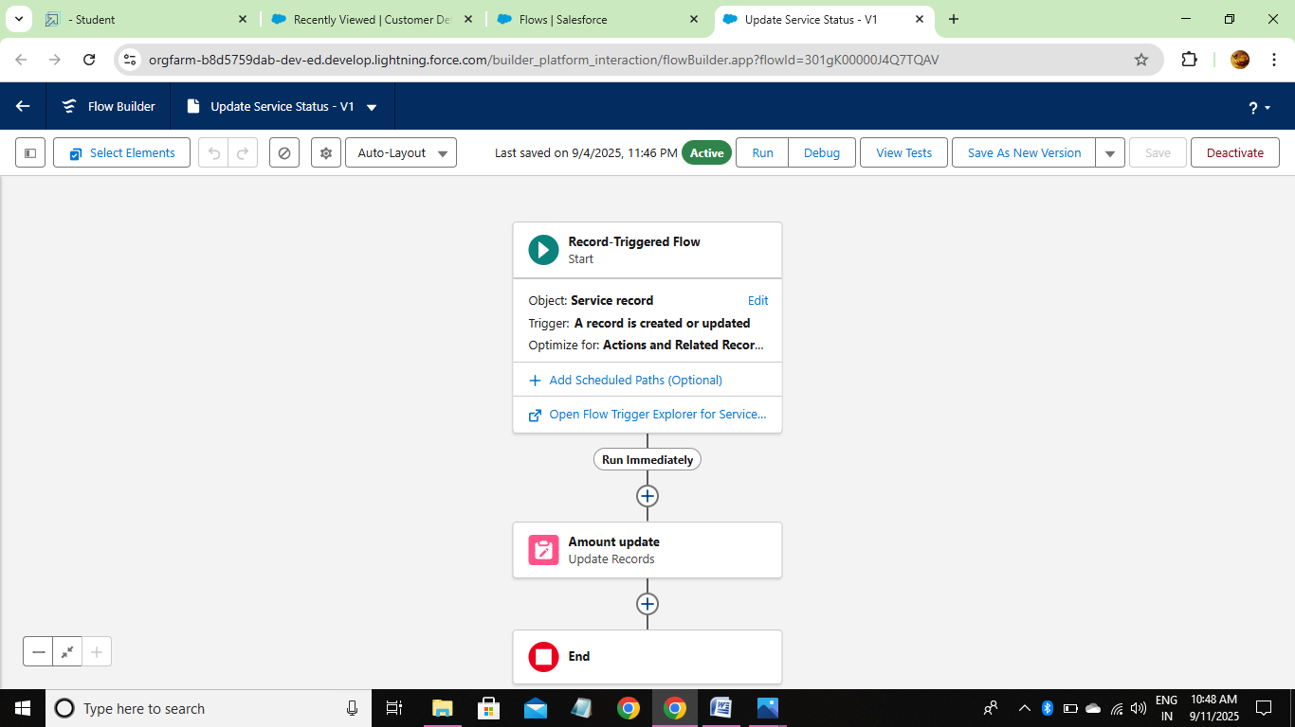

* + - * Apex Trigger :
* Apex Handler

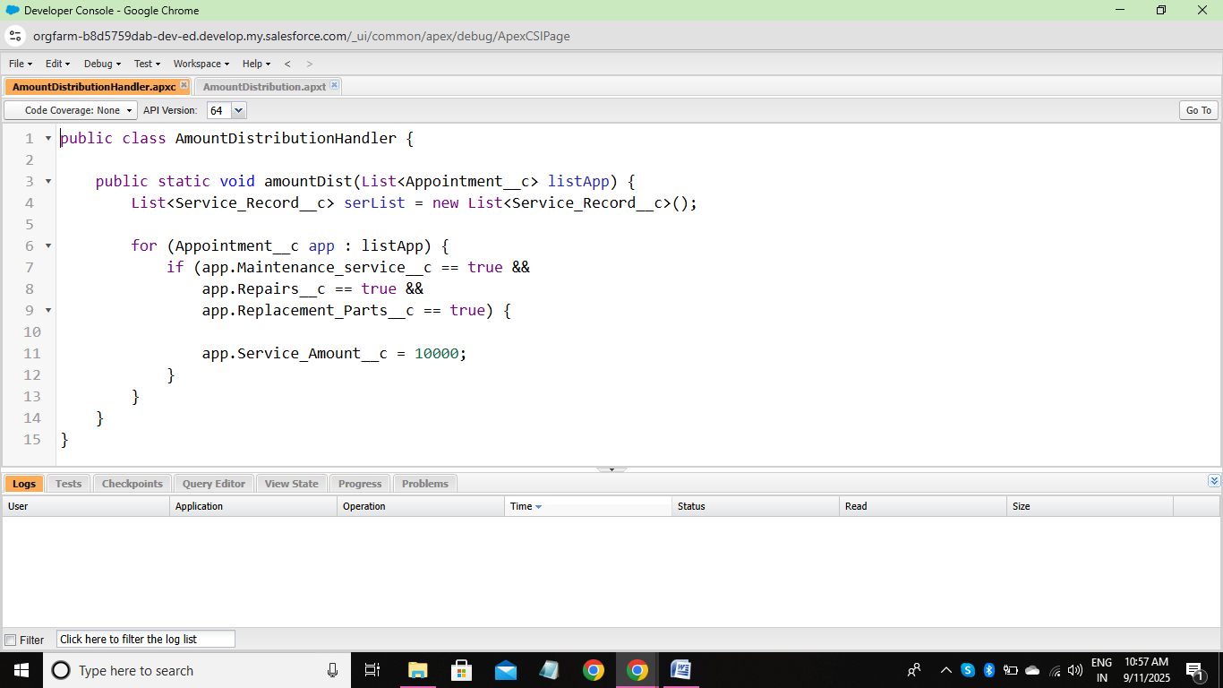

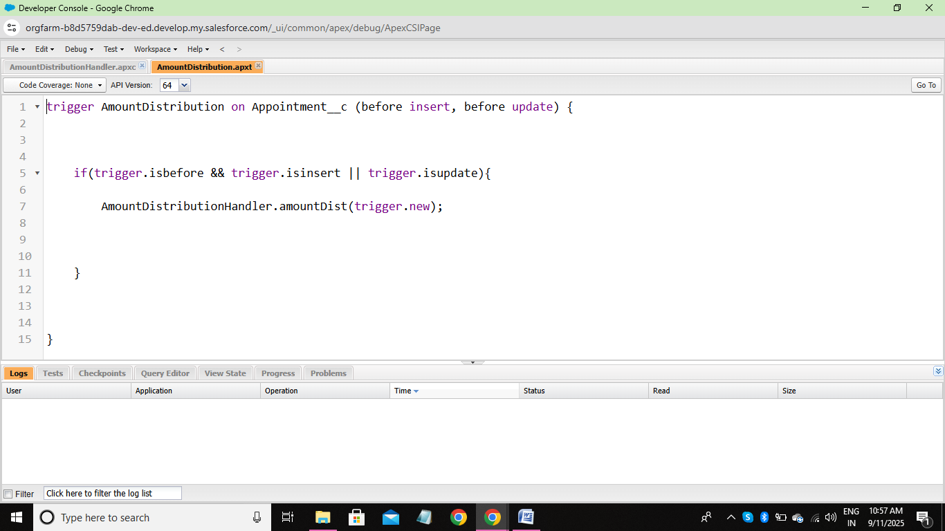

* + - * Created Reports :
* A Report Folder
* **Test S**
* **Cenarios**

1. Folder Creation

* Create a new report folder.
* Validate folder name uniqueness.
* Ensure default folder is visible.

2. Folder Permissions

* Share folder with specific users/roles.
* Test read-only vs. edit access.
* Verify restricted users cannot access.

3. Folder Operations

* Rename an existing folder.
* Delete a folder with/without reports.
* Move reports between folders.

4. Report Management

* Add reports into folder.
* Open reports from the folder.
* Validate report visibility after moving.

5. Negative Testing

* Attempt creating duplicate folder names.
* Try deleting a folder without permission.
* Access reports in a folder without proper rights.

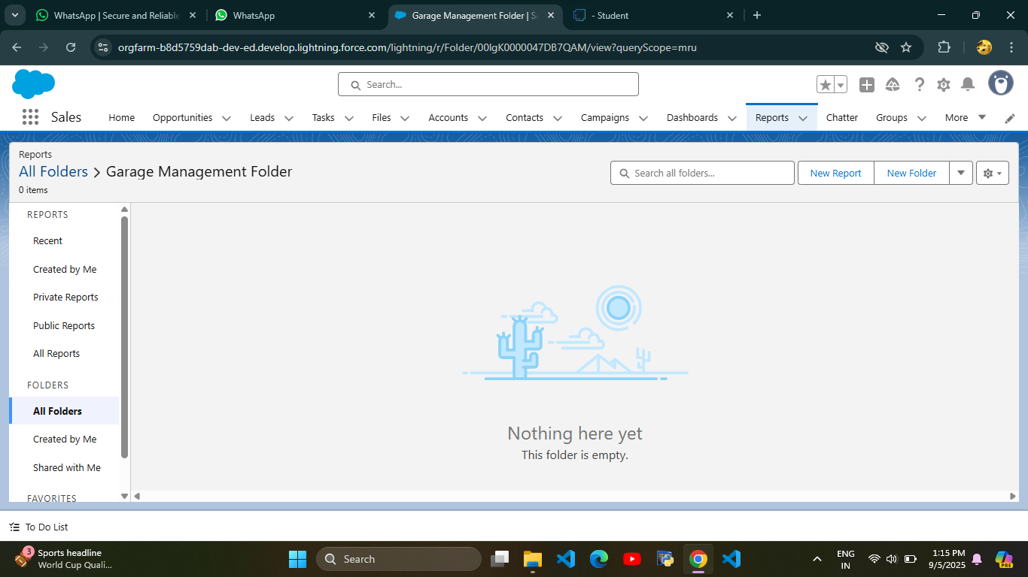

* Sharing A Report Folder
* **Test Scenarios**

1. Folder Sharing

* Share a folder with a specific user → verify user can access.
* Share with a role (e.g., Manager) → all role members should get access.
* Share with a public group → confirm access for group members.

2. Access Levels

* Assign Viewer access → user can only view reports.
* Assign Editor access → user can view and edit reports.
* Assign Manager access → user can view, edit, and re-share folder.

3. Permission Validation

* Remove sharing access → user should lose folder visibility.
* Downgrade access (Manager → Viewer) → confirm restrictions apply.
* Test overlapping permissions (user in multiple roles with different rights).

4. Negative Testing

* Try to share with invalid users.
* User without access should not see the folder in their list.
* Check unauthorized user cannot open reports via direct link.

5. Test Data

* Users with different roles: Admin, Manager, Mechanic, Guest.
* A sample report folder with multiple reports.
* Public group (e.g., ServiceTeam).

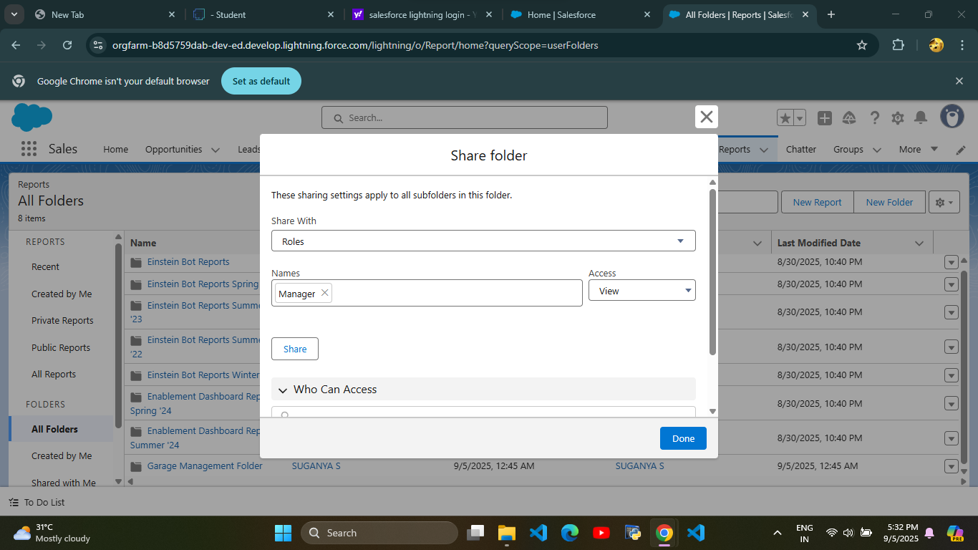

* Report Types
* **Test Scenarios**

1. Creation & Configuration

* Verify that a new custom report type can be created successfully.
* Ensure the display label, API name, and description are saved correctly.
* Check that the primary object and related objects are selectable as per business requirement.
* Validate object relationships (with or without related records).

2. Field Availability

* Ensure all fields of the primary and related objects are available in the report.
* Verify custom fields appear correctly.
* Check field-level security (restricted fields should not be visible).

3. Report Building

* Create a report using this custom report type.
* Validate the report loads with correct fields.
* Apply filters and confirm accurate filtering.
* Test sorting, grouping, and summary fields.

4. Data Validation

* Cross-check data in the report with raw records from Salesforce objects.
* Validate counts, sums, averages, and roll-ups.
* Confirm relationship joins fetch correct records (e.g., "with at least one related record" vs. "may or may not have").

5. Access & Permissions

* Verify report visibility based on user profiles/roles.
* Confirm restricted users cannot access unauthorized report types.

6. Usability

* Ensure naming conventions are meaningful.
* Check that users can easily identify and use the report type.

7. Negative Testing

* Try deleting fields from report type and confirm handling.
* Validate system behavior when objects/fields are deleted.
* Ensure invalid filter conditions return appropriate messages.

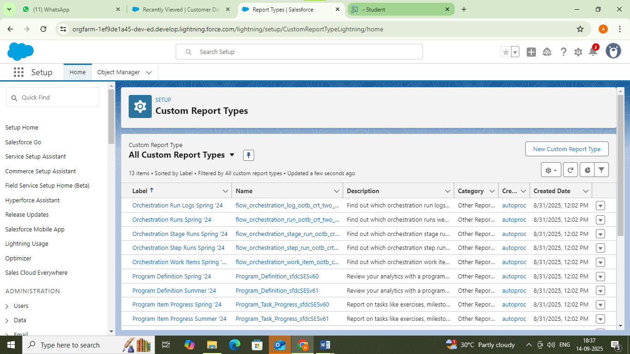

* Reports
* **Test Scenarios**

1. Functional Testing

* Create, edit, delete reports.
* Verify folders (Created by Me, Shared, Public, Private).
* Check search & filters.

2. Data Validation

* Ensure report data matches source records.
* Validate totals, counts, and calculations.

3. UI Testing

* Check layout, navigation, and scrolling.
* Verify report details (name, description, owner, date).

4. Security Testing

* Test role-based access.
* Confirm private reports aren’t visible to unauthorized users.

5. Performance Testing

* Measure load time with large datasets.
* Check system behavior under multiple users.

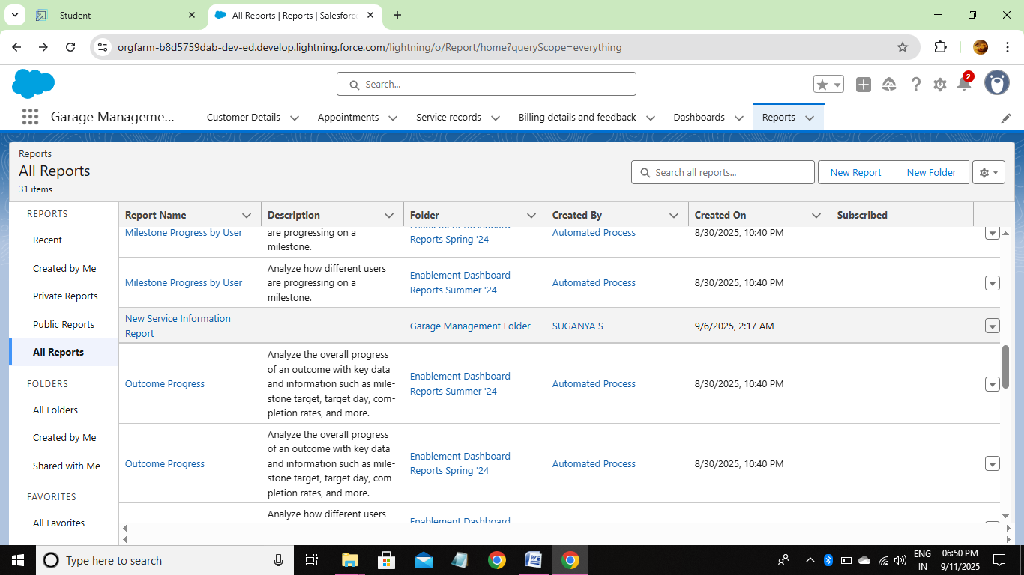

* + - * Dashboards :
* Dashboard Folder

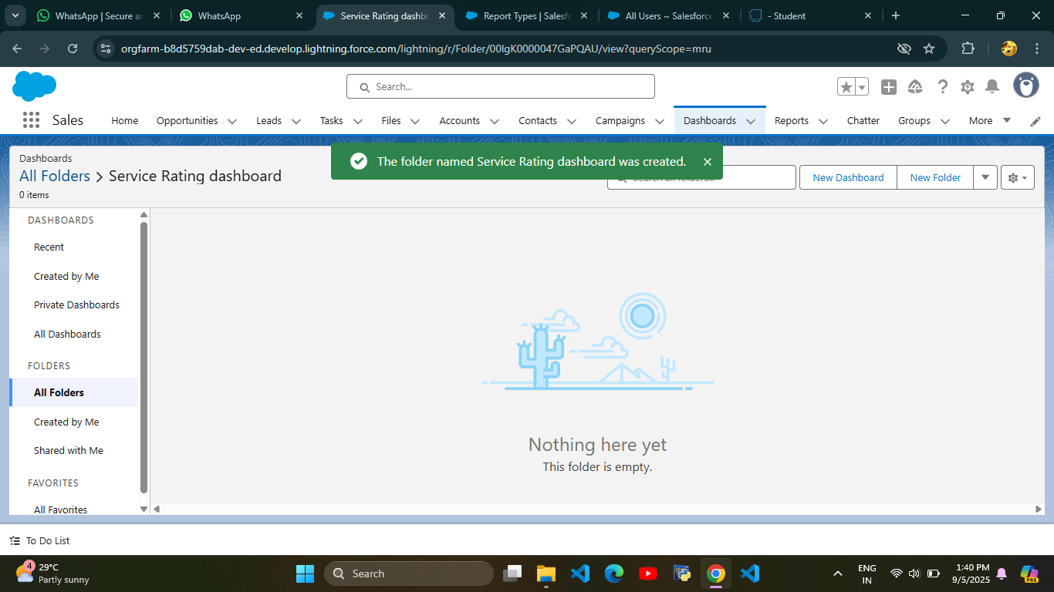

* Dashboard

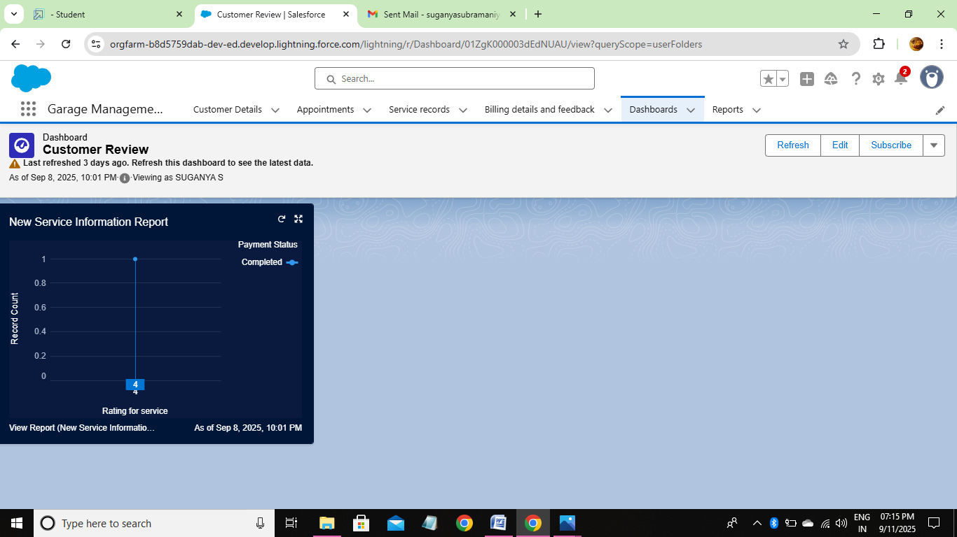

* + - * Created Records :

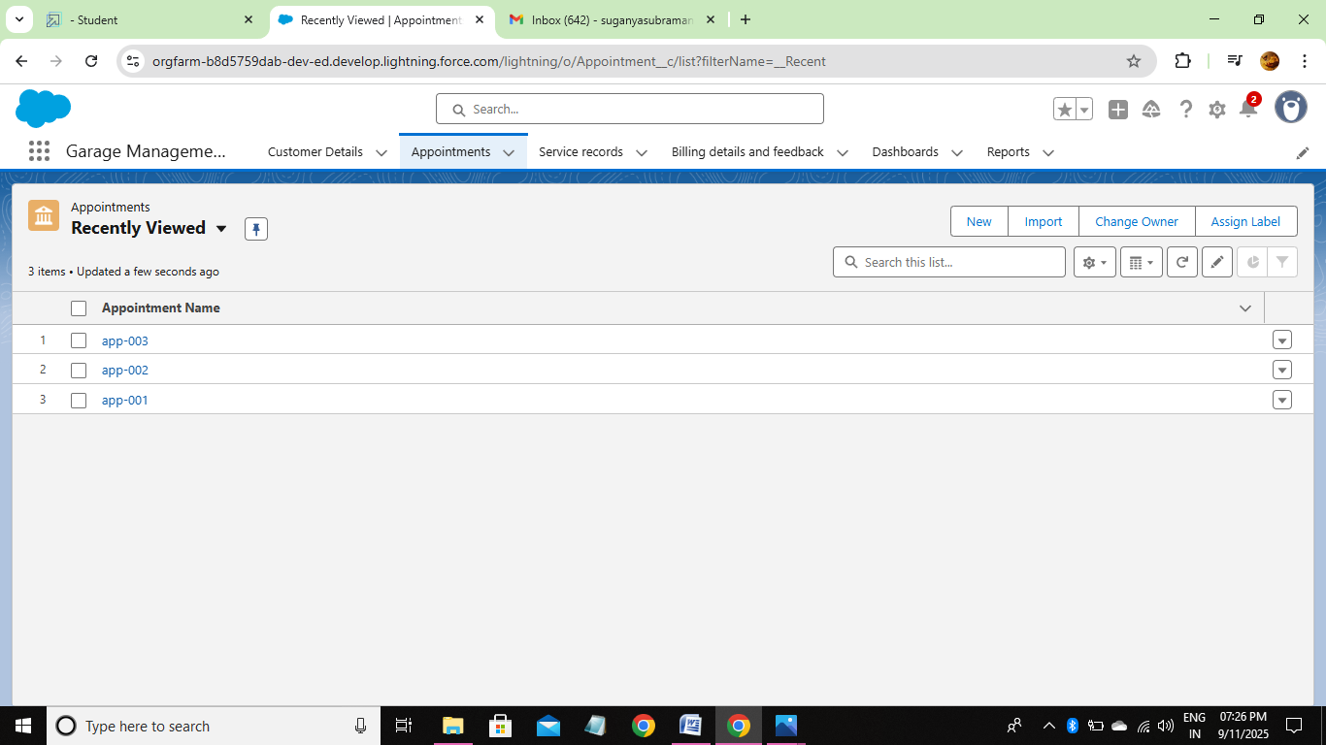

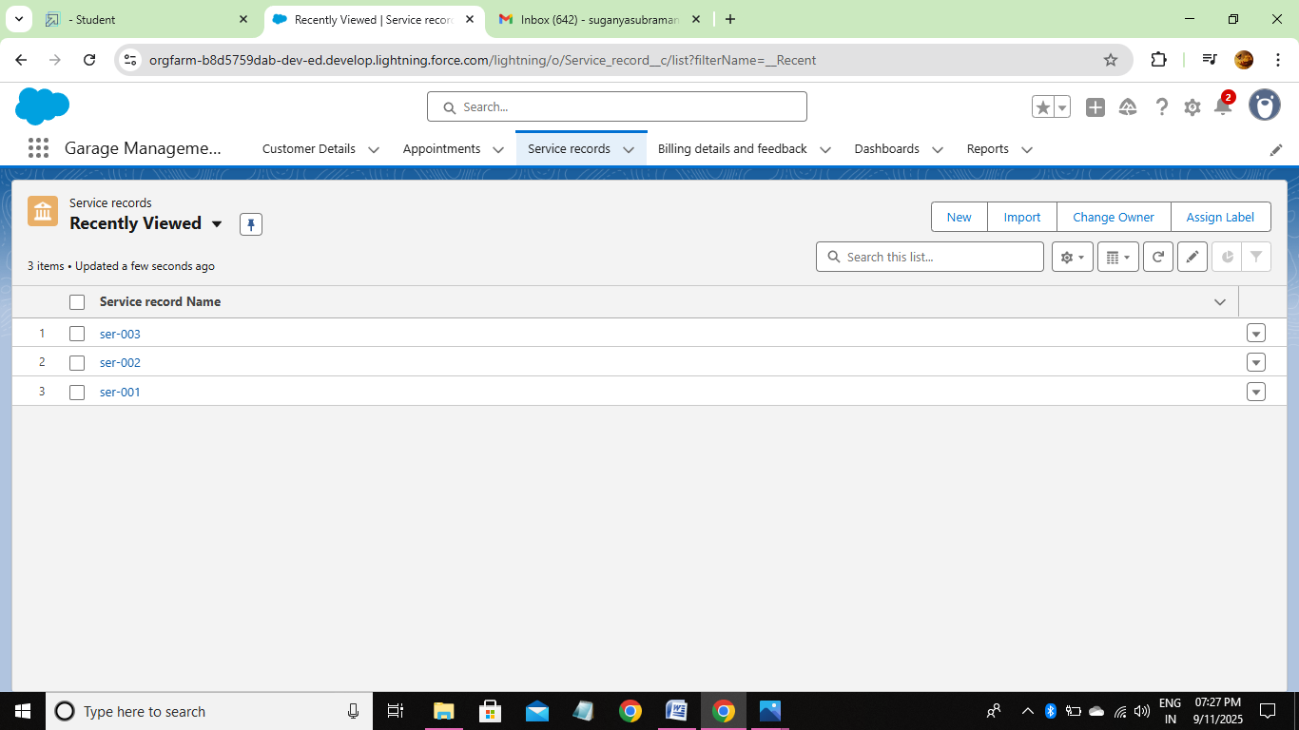

# **CONCLUSION :**

The Garage Management System effectively streamlines the operations of vehicle servicing and repair through a structured, automated Salesforce application. It enhances efficiency in managing appointments, service records, and billing, while improving communication between customers and staff.

# **APPENDIX :**

**Source Code** : Provided in Apex Classes and Triggers

**AmountDistributionHandler.apxc :**

public class AmountDistributionHandler {

    public static void amountDist(List<Appointment__c> listApp) {

        List<Service_Record__c> serList = new List<Service_Record__c>();

        for (Appointment__c app : listApp) {

            if (app.Maintenance_service__c == true &&

                app.Repairs__c == true &&

                app.Replacement_Parts__c == true) {

                app.Service_Amount__c = 10000;

            }

        }

    }

}

**AmountDistribution.apxt :**

public static void amountDist(Appointment__c app) {

    amountDist(new List<Appointment__c>{ app });

}